# The Ultimate JavaScript Master Series

# Part 1

## 01 - Getting Started - 01 Welcome

This will teach the fundamentals of programming and Javascript.

## 01 - Getting Started - 02 What is JavaScript?

What is JavaScript

What can you do with it?

Where does JavaScript code run?

What’s the difference between JavaScript vs ECMAScript?

What is JavaScript?

It is one of the most popular and widely used programming languages in the world. It is growing faster that any other programming languages. (Ah… Java and JavaScript are not the same. Der).

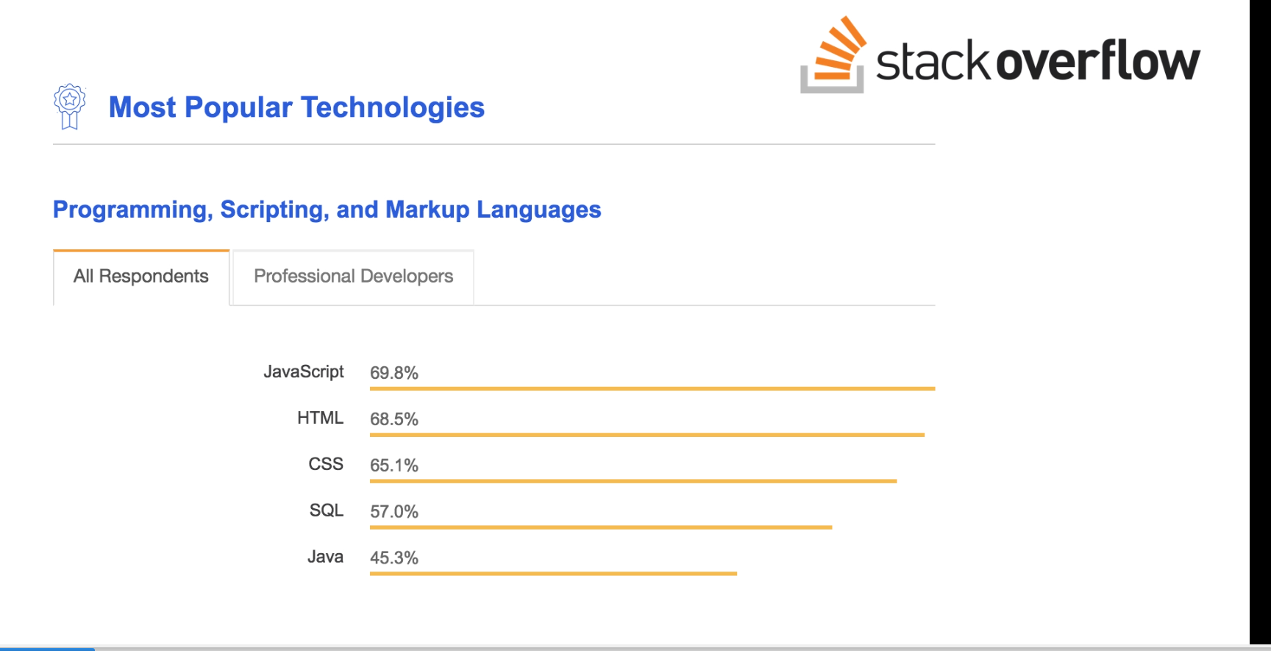

Big companies like Netflix, Walmart, and Paypal build Entire applications around JavaScript. Average salary is $72,000 per year. (According to glassdoor.com?)

You can work as a front end developer, or a back end developer, or a full-stack Developer.

What can you Do with JavaScript? For a long time, javascript was only used in browsers to build interactive webpages. “Some developers refer to javascript as a toy language. But those days are gone because of huge community support and investments by large companies like facebook and google.”

You can build full blow web or mobile apps, as well as real-time networking apps like chats and video streaming services, command-line tools, or even games.

Where does JavaScript Code run? It was originally designed to run only in browsers. Every browser has a “JavaScript Engine” that can execute javascript code. E.g., the javascript engines in firefox and chrome are Spidermonkey and v8. In 2009 an engineer named Ryan daul, took the opensource JavaScript Engine in chrome, and embedded it inside a C++ program. He called the program Node.

Node is a C++ program that includes googles V8 JavaScript engine. Using this, we can run JavaScript code Outside a browser. We can pass our JavaScript code to Node for execution. This means, with JavaScript, we can build the back end for our web and mobile applications.

Javascript code can be run inside a browser or in node. They both provide a ‘runtime?’ environment for our javascript code.

What is the difference between JavaScript and ECMAScript?

ECMAScript is just a Specification. JavaScript is a programming Language that Conforms to this specification.

We have a programming language called ECMA, which is responsible for defining standards. They take care of this ECMAScript Specification.

The first version of ECMAScript was released in 1997. In 2015, ECMA has been working on annual releases of a newer specification. E.g., in 2015, they release ES2015/ES6. This specification defined Many new features for JavaScript.

Every browser has a JS engine, and we can write code here without an other tools. Let’s inspect a chrome window.

Select the Console Tab. This is our JavaScript Console. “We can write any Valid JS code here”.

*console.log('Hello World');*

*console.log('Hello World');*

*VM451:1 Hello World*

*undefined*

We can see the hello world Message on the console. (The VM451:1 is an artifact).

We can also write mathematical expressions here.

*2+2*

*2 +2*

*4*

alert(‘yo’)

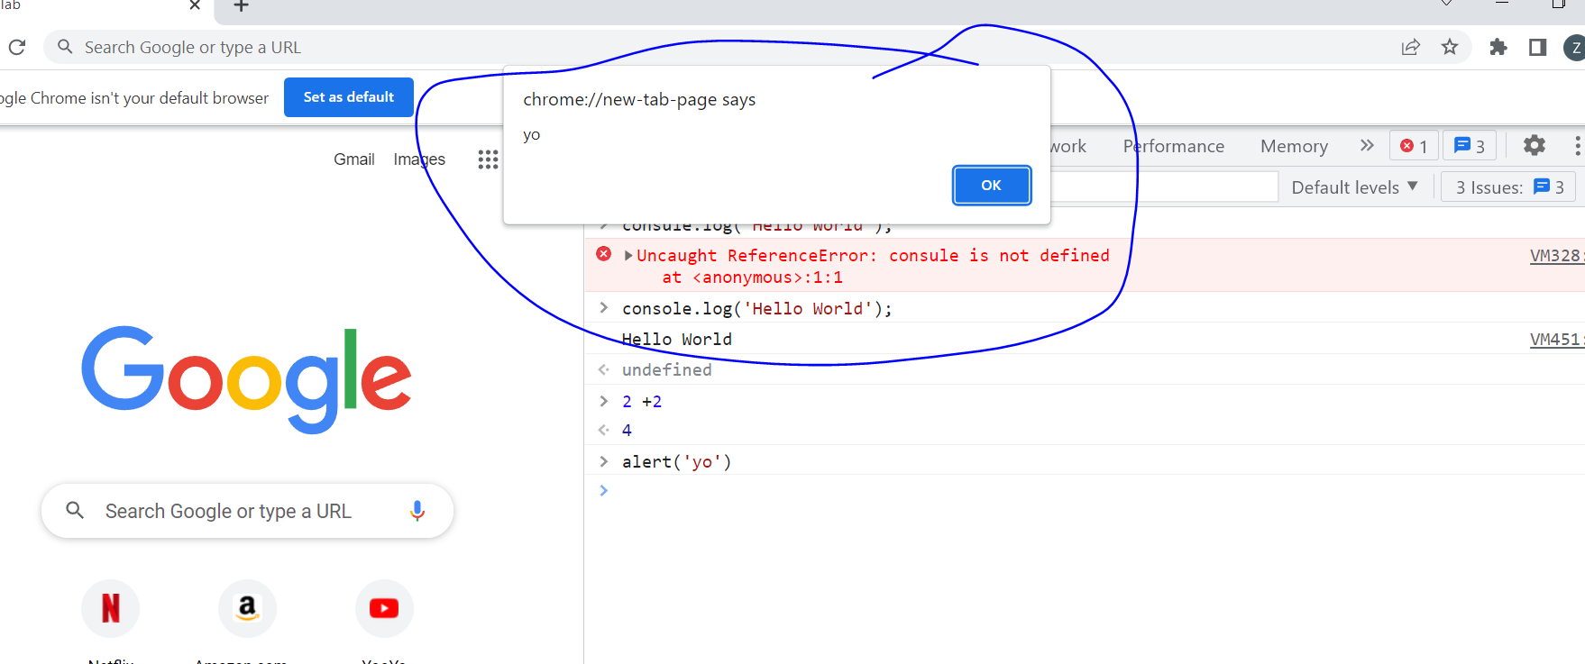

## 01 - Getting Started - 03 - Setting Up the Development Environment

VSCode, Sublime Text, and Atom are all code Editors. Mosh prefers VSCode.

We will also install Node, from Nodejs.org. You don’t Need Node to execute JS, because you can execute it inside a browser. But it’s good to have node, because you can use it to install Third Party Libraries.

Create a folder, e.g., js-basics, and drag and drop in VSCode.

Let’s add a new file:

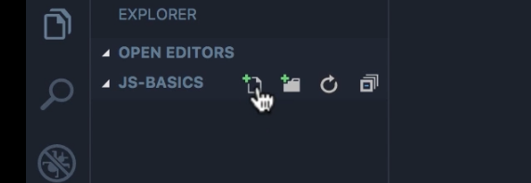

“Now you don’t really need to know html in order to take this course, but if you want to be a front end developer, you should know your html well.”

Make a boilerplate doc !. We’ll use this as a host for our JS code. Save.

Open index.html with live server.

In order to write JS, we need a script element. There are two places where we can add this. In the head section, or the body section.

The best practice is to put the script element at the end of the body section, After all the ‘existing?’ elements.

Why is this a best practice? One reason is that the browser parses this file from top to bottom. If you put the script element in the head, there would be a lot of JS code there, and your browser may get busy parsing and executing that JS code and it won’t be able to render the Content of the page. This will create a bad user experience. The user sees a white or blank webpage while your browser is busy parsing and executing your javascript code.

The second reason is that almost always the code between script elements needs to talk to the elements on this web page. For example we may wish to show or hide some elements. So by adding the code here at the end of the body section we’ll be confident that all these elements will be rendered by the browser.

There are exceptions to this rule. Sometimes you are using third party code that has to be placed in the head section. But these are exceptions. As a best practice, you should add your JavaScript code at the end of the body section.

Let’s write some code:

 <body>

    <h1>Hello World</h1>

    <script>

console.log('Hello World');

    </script>

  </body>

The highlighted code is a statement. A statement is a piece of code that expresses an action to be carried out. In this case, we want to *log* a message *‘Hello World’*, on the *console*.

All statements in JavaScript should be terminated by a semicolon ;

console.log('Hello World');

What we have here in between single “code?” is called a string. A string is a sequence of characters.

In JavaScript we also have this notation: // We can add two slashes and this represents a comment.

<script>

        // Comment

        console.log('Hello World');

    </script>

Here we can add some description to our code and this description is ignored by the JavaScript engine. It is not executed. It is purely for documenting the code when you want to explain to other developers why you have written the code this way. You don’t want to explain what the code does because that should be clear in the code itself. (Mosh highlights the console statement). We want to explain Why’s and Hows.

  <h1>Hello World</h1>

    <script>

      // This is my first JS code.

      console.log("Hello World");

    </script>

Let’s open our console again the browser. alt ctrl i

## 01 - Getting Started - 05 - Separation of Concerns

In real world applications we have thousands or even millions of lines of code. Therefore, writing in the script element is oftentimes not practical. We don’t want to write all the code inline here. We want to extract and separate our JS code from our html code.

Mosh utilizes a metaphor in which we recognize that bedrooms stores your bed and your clothes. We don’t store are clothes in the kitchen. This is what we call the Separation of Concerns. We want to separate HTML--which is all about content--from JavaScrip, which is all about behavior.

How should your webpage behave? What should happen when we hover our mouse over a given element? Maybe something should pop up or be hidden. We’ll use JavaScript to implement behavior.

In VSCode let’s start a new file will call index.js. Let’s cut our JS code from our html file, and paste it in index.js. In this application we have a single file, a single JavaScript file. In a real world application we have hundreds or even thousands of JavaScript files. We’ll eventually learn how to combined these files into a bundle and ‘serve’ that bundle to a ‘client’.

Now that all are JavaScript code is in a separate file, we need to reference that file here.

Let’s add an attribute here (in our HTML document):

<script></script>

<script src="index.js"></script>

This tells the browser that are JavaScript code is in index.js.

When we open our browser, we note that the Hello World message is still up, which indicates that our code is still working. Huzzah!

## 01 - Getting Started - 06 - JavaScript in Node

We navigate to our js-basics folder. Then we type (in command prompt… not in node?)

*node index.js*

*C:\Users\Mr. Artifice\Desktop\js-basics>node index.js*

*Hello World*

We get the same messages on the consol. As we can see, node is a program that includes google’s V8 JavaScript engine. We can give it a piece of JavaScript code and it will execute that code for us just like we can in a browser. (This works in both command prompt and the node command prompt). So, node is a runtime environment for executing JavaScript code.

Here’s a tip from Mosh:

VSCode includes an integrated terminal, so you don’t have to open up a separate terminal window. Under view, you’ll find the “Terminal” option. Note that our terminal is pointing to the same folder where we created our files… You don’t have to explicitly navigate to this folder. (Make sure you have the index selected).

Here you can type node index.js and get the same output. (I have a big error message from my previous shell manipulations).

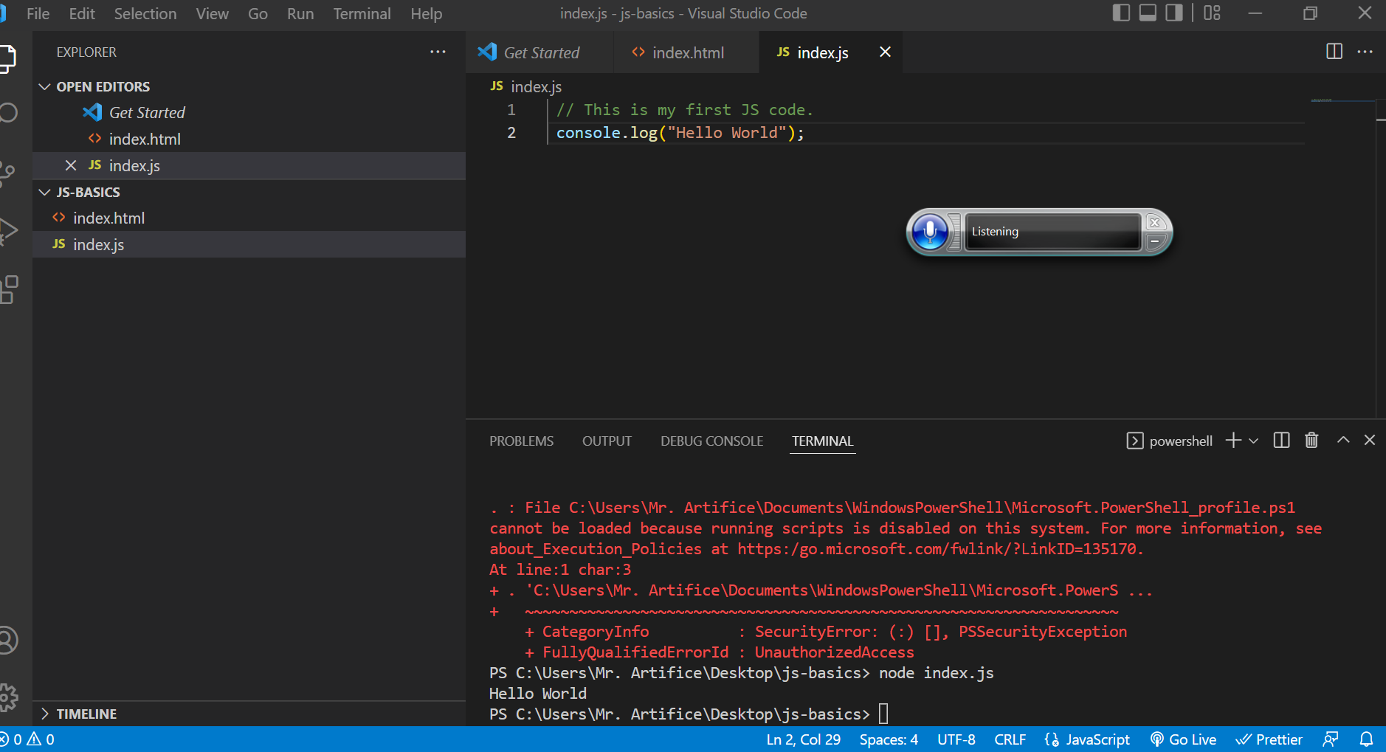

In this course we will no longer work with node. Node is a separate topic for which mosh has devoted a course with 14 hours of content.

## 02 - Basics - 01 - Variables - 5.36

Variables are one of the most fundamental concepts in JavaScript or any other programming language.

In programming we use a variable to store data temporarily in a computer’s memory.

We store our data somewhere, and give that memory location a name:

Memory

|  |  |  |  |
| --- | --- | --- | --- |
| Variable |  |  |  |

Variable Name.

With this Name, we can read the data at the given location in the future.

Metaphor!!!

Imagine putting items in various boxes, and labeling each box. Now, you can readily find your stuff. A variable is like this box. What we put inside this box is the value we assign to a variable; that’s the data. And the label that we put on the box is the Name of our Variable.

In index.js let’s declare a variable. In the old days before ES6 we used the *var* keyword to declare a variable.

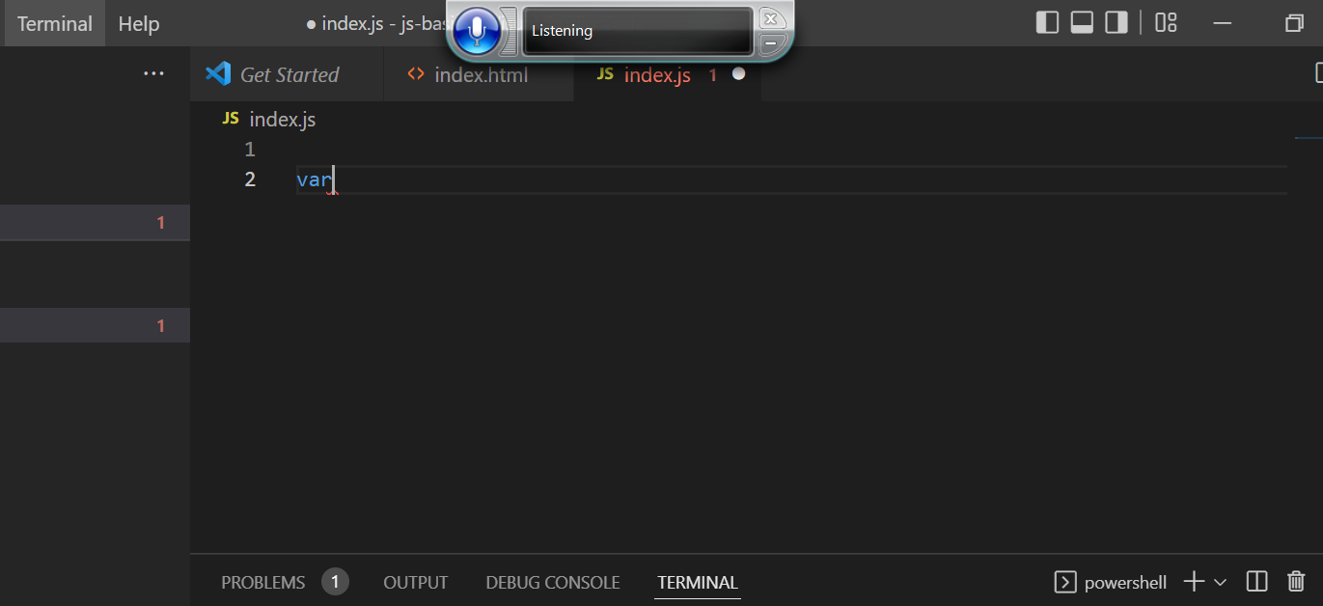

However, there are issues with VAR as we will discover later in the course.

After ES6, the best practice is to use the *let* keyword to declare a variable.

let

Let’s give this variable a name or an identifier. This is like the label we put on a box. We’ll call it *name* and terminate it with a semicolon.

let name;

Let’s add this on the console and see what happens.

*console.log(name);*

let name;

console.log(name);

In the console, we see *undefined.* (I also have loads of error messages, for whatever reason).

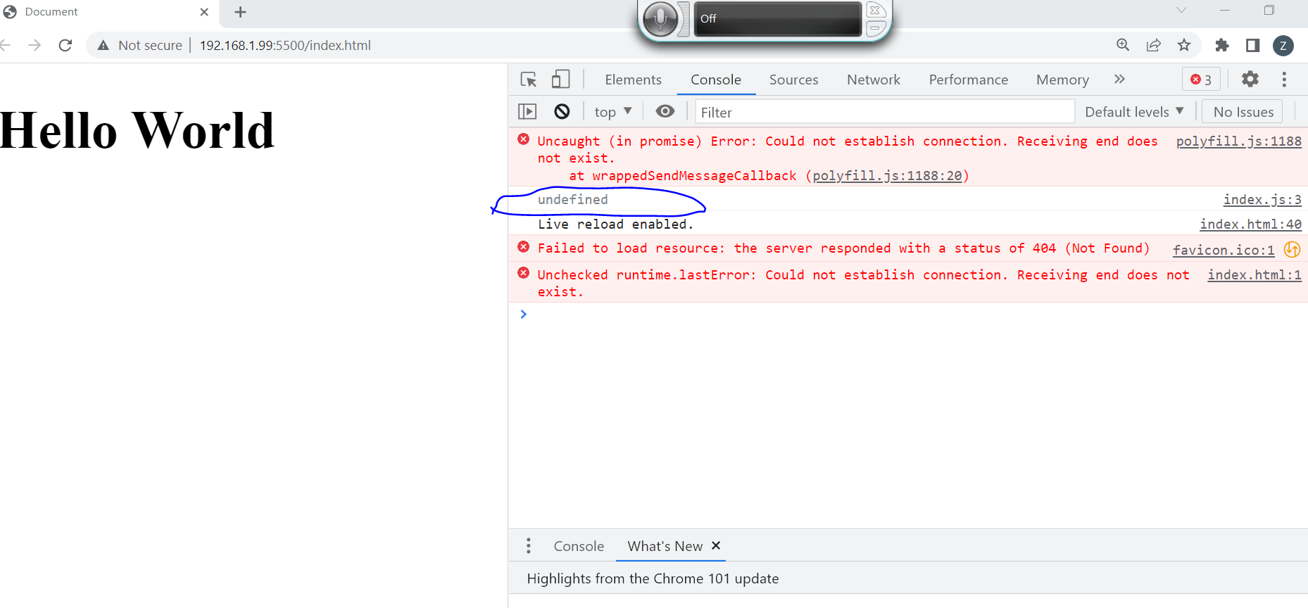

By default variables that we define in JavaScript… Their value is undefined.

We can optionally initialize this variable:

let name;

console.log(name);

= a string, which is a sequence of characters.

let name = 'Mosh';

console.log(name);

We can use single or double quotes. It is more common to use single quotes for declaring strings in JavaScript.

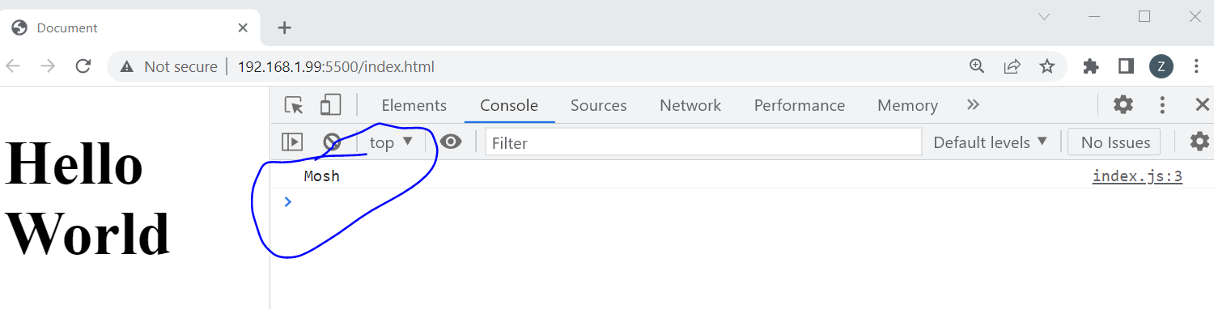

Now we see Mosh on the console.

let name = 'Mosh';

console.log(name);

We have declared a variable called *name* and we have set it to this (‘Mosh’) value, to this string.

There are a few rules for naming the variables.

They cannot be a reserved keyword. For example we can’t use the keyword *let*. If we tried to use one of these names, we will get an error.

Note this red underline:

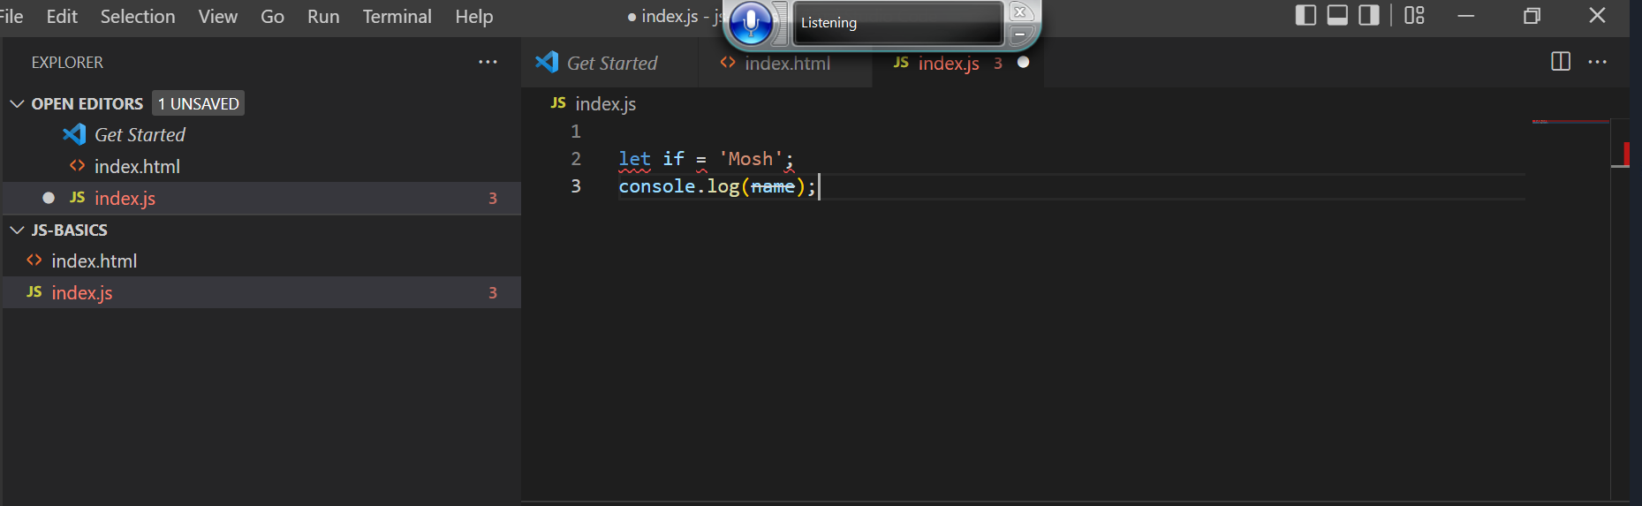

This is indicating that this is not a valid identifier.

Our second rule is that the name should be meaningful. The name should give some clue as to what the purpose of the variables are. What kind of data are we storing at that memory location. Always use meaningful and descriptive names.

The third rule is that they cannot start with a number.

The fourth rule is that they cannot contain a space or a hyphen.

For example, *let firstName .* Mosh is using camel notation, so the first letter of the first word is lowercase, and the first letter of every word after should be uppercase.

Camel notation is the convention used in JavaScript to name are variables.

The fifth rule for variable names is that they are case sensitive. E.g., the following variables are different:

*let firstName;*

*let FirstName;*

The sixth rule is that if you want to declare multiple variables there are two ways to do this. You can declare them on one line and separate them using a comma… e.g.,

*let firstName, lastName;* (In this case Mosh has not initialized either of these variables. They are both undefined).

We can optionally initialize one or both of them. E.g.,

*let firstName = ‘Mosh’, lastName;* (lastName is undefined) or… Up

*let firstName =’Mosh’, lastName = ‘Hamedani’;*

But the modern, best practice is to declare each variable on a single line. Like so:

*let firstName =’Mosh’;*

*let lastName = ‘Hamedani’;*

## 02 - Basics - 02 - Constants

Let’s make a variable called interest rate:

*let interestRate = 0.3.;*

This is the initial value; we can always change it later.

let interestRate = 0.3;

interestRate = 1;

If we log this on the console, we’ll see the new value… right?

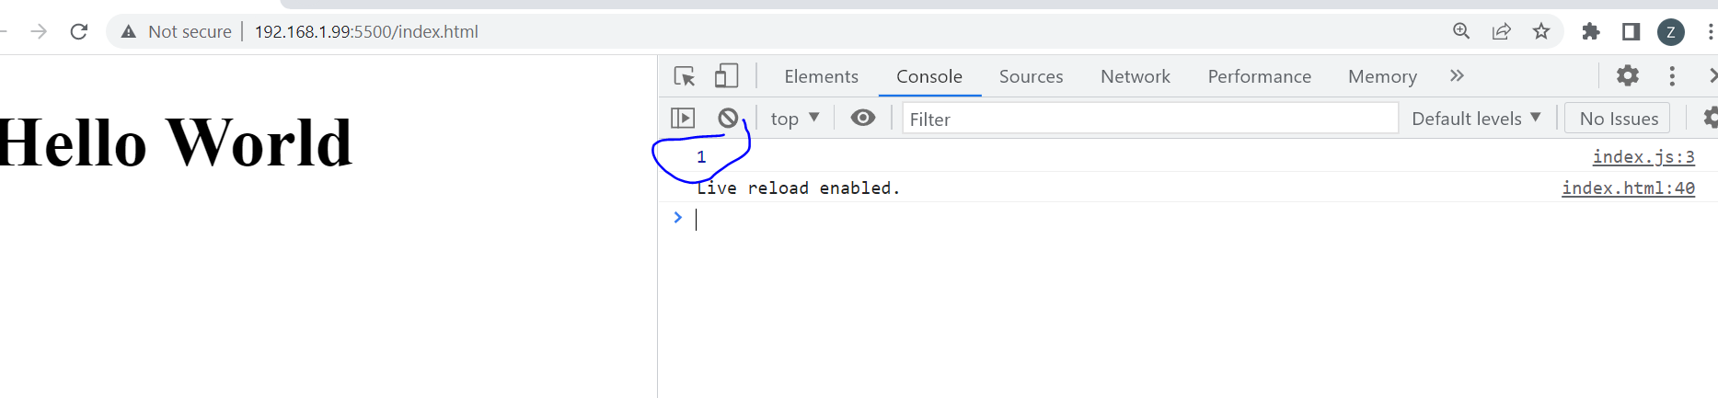

There it is. 1 on the console.

However, there are real world situations in which we don’t want the value of that variable to change… Because otherwise it’s going to cause all kinds of bugs in the application. So, we use a Constant instead of a variable.

The value of the variable changes, but the value of a constant.

So, let’s change *let*, to *const*:

const interestRate = 0.3;

interestRate = 1;

console.log(interestRate);

When we save these changes, we’ll see an error in the console on line two.

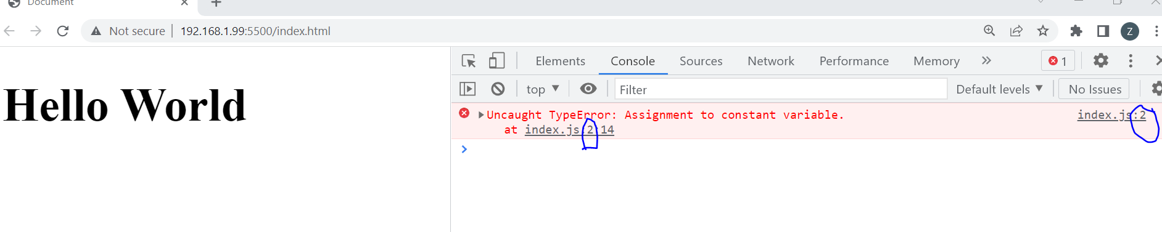

If we click the error circled above:

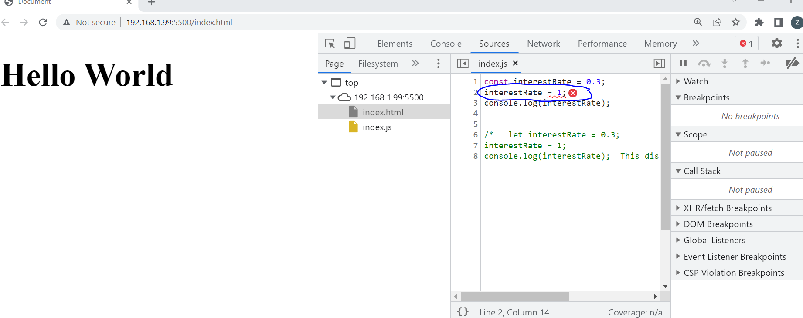

We can see the line in code where this error occurred. So… we cannot reassign a constant.

The best practice is that if you don’t need to reassign, constant is your best choice. If you need to reassign a variable, use let.

## 02 - Basics - 03 - Primitive Types

What are the kind of values we can and assigned to a variable? We have seen strings… but we have more types.

In JavaScript we have two categories of types:

1. Primitives AKA Value Types
2. Reference Types.

For Primitives, we have:

* Strings
* Number
* Boolean
* undefined
* null

E.g.,

let name = 'Mosh';

We have a variable called name, which is set to a string. This: “*‘Mosh’*” is what we call a String literal. This is a fancy name for a string.

Let’s declare a variable and set it to a number.

let age = 30;

This is what we call a number literal.

Let’s declare a Boolean. A Boolean can be either true or false.

Let is approved to be true:

let isApproved = true;

We use Boolean in situations where we want to have some logic. E.g., If the order is approved, it needs to be shipped. So, the value of Boolean variable can be true or false. (Both true and false are reserved keywords, so they cannot be variable names.)

(Are undefined variables ones that aren’t initialized? What is initialized?).

Ah, yes. If we do not initialize a variable, then by default it is undefined.

let firstName;

We can also explicitly set the variable to undefined:

let firstName = undefined;

However, that is not very common. In contrast, we have another key word, *null*.

let lastNames = null;

We use *null* in all situations that we want to Explicitly clear the value of a variable. E.g., We might want to present the user with a list of colors. If the user has no selection, we want to set the:

*selectedColor* variable to null:

let selectedColor = null;

In the future… if the user selects a color, we will reassign this variable to a color like ‘red’.

let selectedColor = 'red'

But then, if the user clicks red again, we want to remove the selection and set this back to null. We use null in situations where we want to clear the value of a variable.

These are the examples of primitives/value types.

let name = 'Mosh';  //This is a String Literal

let age = 30;  //Number Literal

let isApproved = true;  // Boolean Literal

let firstNames = undefined;  //undefined

let lastNames = null; //null

## 02 - Basics - 04 - Dynamic Typing

Something that separates JavaScript from other programming languages is that java script is a dynamic the language.

There are two types of languages:

* Static (statically-typed)
* Dynamic (Dynamically-typed).

In static languages, when we declare a variable, the Type of that variable is set and it cannot be changed in the future: *string name = ‘John’;*

Whereas in a dynamic language, the type of a variable can change at runtime: *let name = ‘John’;*

Let’s examine our code:

let name = 'Mosh';  //This is a String Literal

let age = 30;  //Number Literal

let isApproved = true;  // Boolean Literal

let firstName = undefined;  //undefined

let lastNames = null; //null

At the top, we have declared (let?) this name variable, and we have “set that to a string”. So, the type of name is currently a string, but it can change in the future.

Let’s go to our console, and execute some JavaScript code. We have a typeof operator, which we can use to check the type of variable.

So, we type *typeof* followed by our name variable *name*

*typeof name*

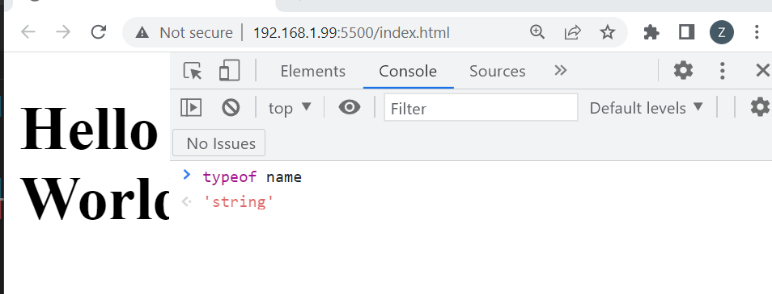

If we reassign name to a different value, like a number (*name = 1;*) and check it’s type:

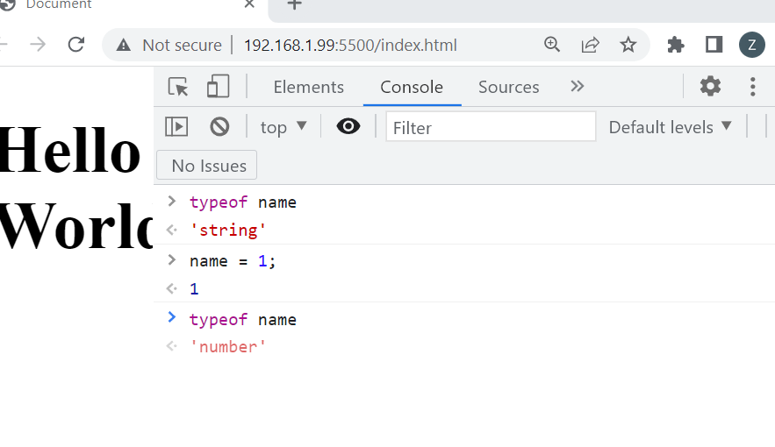

The type is now changed to number. *‘number’*

This is what we call a dynamic language. Unlike static languages, the type of these variables will be determined at run time, based on the values we assign to them.

Let’s look at some more examples of the typeof operator. (typeof using other reserve key word).

(Command^^) To clear the console press ctrl L.

*typeof age*

‘number’

Type of age is a number.

Let’s change age to a floating point number in the console:

*age = 30.1*

*30.1*

Note that when we look at typeof, age is still a number.

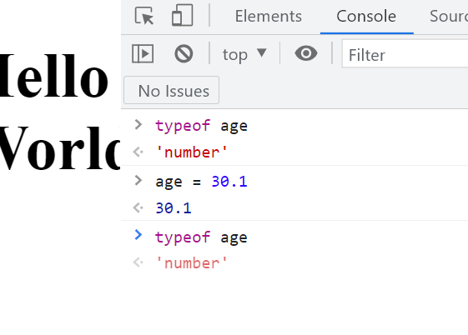

In JavaScript, unlike other programming languages, we don’t have two types of numbers: we don’t have floating point numbers and integers. All numbers are *oftype* number.

*typeof isApproved*

*‘boolean’*

*typeof firstName*

*‘undefined’*

“That’s funny, because the value of this variable (highlights the word undefined) is undefined, but its type is Also undefined”:

let firstName = undefined;

[Now it seems to me that the typeof is *not* undefined. Surely this is part of the following list of types?   
  
**JavaScript types**

* Boolean type.
* Null type.
* Undefined type.
* Number type.
* BigInt type.
* String type.
* Symbol type.

So then, why is this type undefined?]

“What does this mean? Well, earlier I told you that we have two categories of types. Primitives/Value Types, and Reference Types.

In the Primitive/Value Types we have:

* String
* Number
* Boolean
* undefined
* null

So… undefined is actually a Type… but it is also a Value.

let firstName = undefined;

“In this example, *because* we have set *firstName* to *undefined* as a value, it’s type is also undefined.”

((If we renamed firstName to the string ‘icecream’, string would be the type, but icecream the value… I think)).

How about *selectedColor*?

let selectedColor = null;

key Variable type

word

*typeof selectedColor*

*'object'*

The type of this Variable, is an Object.

## 02 - Basics - 05 - Objects

Reference Types

* Object
* Array
* Functions

An object in JavaScript and other programming languages is like an object in real life. For example, a person has a name, age, address, etc. These are the Properties of a person. The same concept exists and JavaScript.

When we’re dealing with multiple related variables, we can put these variables inside an object.

E.g., here we have two variables: name and age.

let name = 'Mosh';

let age = 30;

They are highly related; they are part of the representation of a person. So instead of declaring two variables, we can declare a person Object. Then instead of referencing these two variables, we can simply reference the person object. It makes for cleaner code.

[[[https://www.freecodecamp.org/news/javascript-object-keys-tutorial-how-to-use-a-js-key-value-pair/

*const desk = {*

*height: "4 feet",*

*weight: "30 pounds",*

*color: "brown",*

*material: "wood",*

*};*

*An object contains properties, or key-value pairs. The desk object above has four properties. Each property has a name,* ***which is also called a key,*** *and a corresponding value.*

*For instance, the key height**has the value "4 feet".* ***Together, the key and value make up a single property.***

*height: "4 feet",]]]*

Let person = an object literal, i.e., curly braces.

*let person =* {};

The curly braces above are what we call an object literal.

'Between these curly braces, we add one or more key value pairs. The keys are what we call the properties of this object. In this case, we want the person object to have two properties, or two keys: name and age.

let name = 'Mosh';

let age = 30;

let person = {

};

Name [this is the key]: [after that, we set the value] ‘Mosh’ [add a comma], [another key value pair] [the key ‘age’] age: [the value] 30

“So we add name here… that’s the key. Then we add a colon, and then after that we set the value… Mosh.”

let name = 'Mosh';

let age = 30;

let person = {

    name: 'Mosh',

    age: 30

};

  name: 'Mosh',

Key Value

“Now we have a person object with two **properties**, or two **keyvalue pairs** ((Highlights name: ‘Mosh’)): name and age.” “And with that, we don’t need those two variables”

let name = 'Mosh';

let age = 30;

let person = [{

**name: 'Mosh',**

**age: 30**

};

Now, let’s log person on the console.

let person = {

    name: 'Mosh',

    age: 30

};

console.log(person);

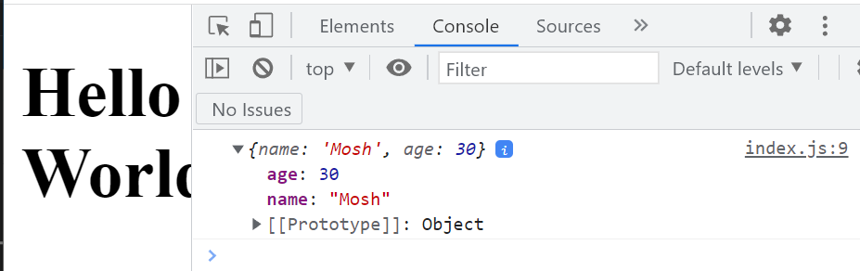

We see our person object {name: “Mosh”, age: 30}. “Note the object literal syntax” - ((He means the curly braces)).

We have a couple key value pairs. ((Mosh wave his mouse over both age and its value, and name and its value)) They ((the key value pairs?)) are the Properties of the person object.

*age:30 Name: ‘mosh’*

Key:value Key: Value

Key Value Pair Key Value Pair

Property Propery

“There are two ways to work with these properties. Let’s say we want to change the name of this person. We’ll need to access the name property.” One way is to utilize Dot Notation. We add the name of our object (person), by typing *person dot*. … and now its properties are displayed in the popup list: It shows the age and the name properties.

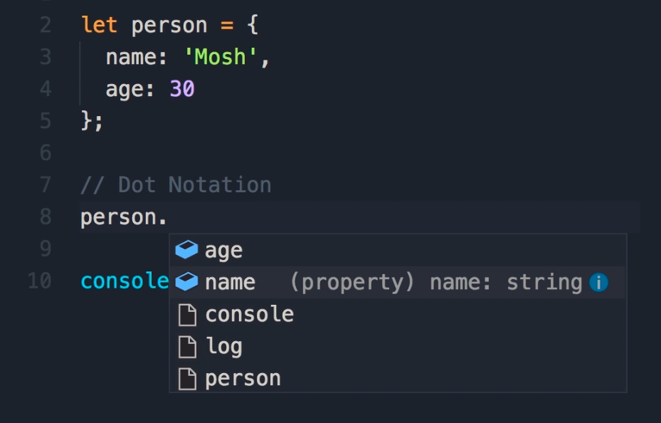

Once we see the property that we wish to alter, we can enter it and do the following:

//Dot Notation

person.name = 'John';

let person = {

    name: 'Mosh',

    age: 30

}

person.name = 'John';

console.log(person);

“We can also use the dot notation to read the value of a property.” “Instead of logging the person object we can log it’s name property.” Now, in the console, it just says “John”.

let person = {

    name: 'Mosh',

    age: 30

}

person.name = 'John';

console.log(person.name);

((In other words, we can reference or display specific properties-key:values in an object)).

The other way to access a property is bracket notation. So instead of dot, we use square brackets… and we pass a string that determines the name of the target property. The name of the target property is name. So… we can change that to, say, Mary”

let person = {

    name: 'Mosh',

    age: 30

}

person.name = 'John';

person['name'] = 'Mary';

console.log(person.name);

“When reading that, we can use the dot notation, or the bracket notation. If we save the changes, now we get Mary”

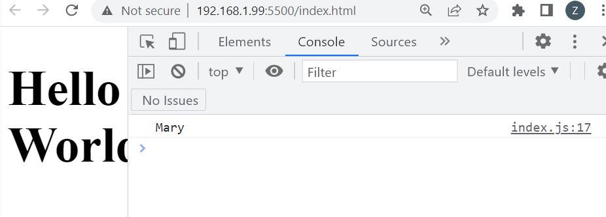

Which notation is better? Dot notation or bracket notation?

“Dot notation is more concise, so that should be your default choice.

*[[So… person is the object, with a couple of properties. Dot notation allows us to select one (or more?) of those properties, and display (probably) or alter it]]*

“…However, bracket notation has its own uses. Sometimes you don’t know the name of the target property until the runtime. E.g., in our user interface, the user might be selecting the name of the target property. In that case, at the time of writing code, we don’t know what property we are going to access. That is going to be selected at runtime by the user.”

“So, we might have another variable somewhere else like “let selection = ‘name’;”. *Let selection*  =’name’ and that can change at runtime.”

let person = {

    name: 'Mosh',

    age: 30

}

person.name = 'John';

let selection = 'name';

person['name'] = 'Mary';

console.log(person.name);

“With this [[person [] = ‘Mary’;]] we can access that property using the bracket notation in a dynamic way. We pass selection here… and we get the same result. [[[Mary on the console]]]

let person = {

    name: 'Mosh',

    age: 30

}

person.name = 'John';

let selection = 'name';

person[selection] = 'Mary';

console.log(person.name);

/* let name = 'Mosh';

let age = 30;

The Object below allows us to eliminate the two variables above

let person = {

    name: 'Mosh',

    age: 30

};

then add

console.log(person);

Now both of the person object properties display in the console.

//Dot Notation

person.name = 'John';

console.log(person);

This displays just John in the Console window, as we have defined the person object (displayed by the console) as merely the name property (using dot notation), which we also redefine.

Next, we also employ bracket notation to define the properties that will be displayed by the console, and its altered values.

let person = {

    name: 'Mosh',

    age: 30

};

//Bracket Notation

person ['name'] = 'Mary';

console.log(person.name);

So... the object is person.

let person = {

    name: 'Mosh',

    age: 30};

Object has a name property.

name: 'Mosh',

The the variable Selection is created, with a value of name.

let selection = 'name';

The console will open the person object's name propery.

console.log(person.name);

The person object is defined with bracket notation as selection, with selection being set with the value of Mary.

The object Person = the value Name,

The variable Selection = the value Name,

The object Person = Selection,

Selection = Mary

The Object display's the name Mary in the console.

*/

let person = {

    name: 'Mosh',

    age: 30

};

//Bracket Notation

let selection = 'name';

person [selection] = 'Mary';

console.log(person.name);

## 02 - Basics - 06 - Arrays - 4.18

Sometimes in your applications you might be dealing with a list of objects. For example, the list of products in a shopping cart. Or, the list of colors the user is selected. We utilize arrays to store such lists.

*let selectedColors*  Note that we aren’t using an indecipherable abbreviation like SC. We have a meaningful name. Let’s initialize this:

*let selectedColors =*

We’ll set this to an empty array. The square brackets are what we call *array literal*. They indicate an empty array.

*let selecteColors = [];*

We can initialize this array and add a couple of items.

let selectedColors = ['red', 'blue'];

Now, let’s log this on the console:

console.log(selectedColors)

let selectedColors = ['red', 'blue'];

console.log(selectedColors)

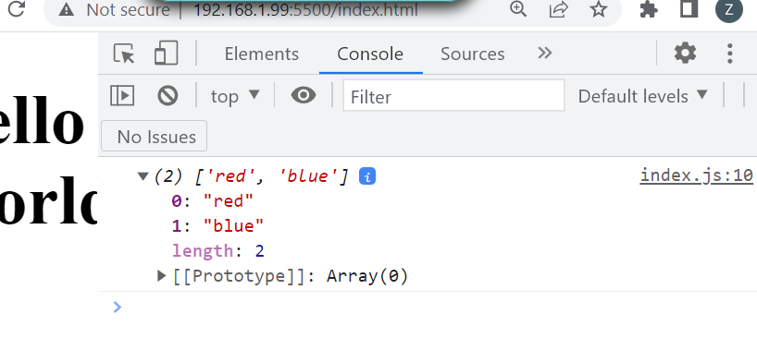

Note that our array has two elements. Also note that each element has an index, and that determines the position of that element in the array.

To access an element in an array, we use that index…

For example, suppose we want to display the first element in the array. We can use the square brackets, and then specify the index. Observe:

let selectedColors = ['red', 'blue'];

console.log(selectedColors[0])

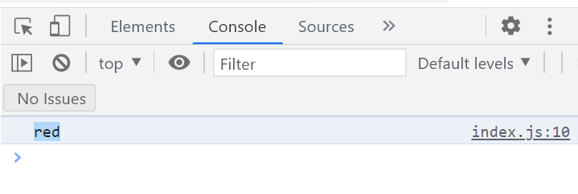

Now, only the first item in the index displays.

The lengths of our arrays and the type of objects in them are dynamic, they can change. For example, we can add other elements besides red and blue and expand our array.

let selectedColors = ['red', 'blue'];

selectedColors[2] = 'green';

console.log(selectedColors[0])

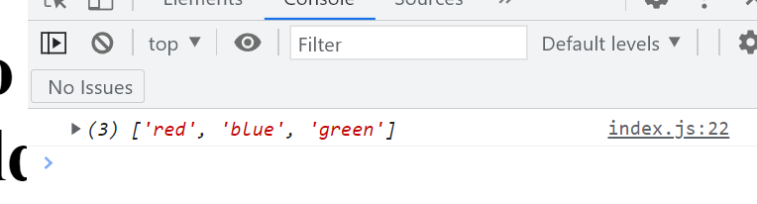

Now we have an array with three elements. Thus, the length is dynamic. It is changeable. Also, the type of objects in this array is also dynamic. Most programming languages do not support mixing different types of objects in the same array.

Here, we will change one of the elements in the array from a colour to a number.

let selectedColors = ['red', 'blue'];

selectedColors[2] = 1;

console.log(selectedColors)

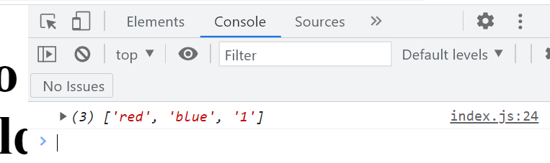

Now we have two strings, and a number.

So, the element type in the array as well as the size of the array is dynamic.

Technically an array is an object. Just like the personal object we previously defined, the array has a bunch of key value pairs or Properties that we can access using the dot notation.

If we examined the already in the console with the typeof function, this is our output:

*typeof selectedColors*

*‘object’*

Note, that this array is indeed an object.

console.log(selectedColors)

In VS code, we can examine the properties of this array/object using the dot notation. VSCode displays a number of properties to choose from for an array in JavaScript.

“Every time we declare an array using square brackets that array will automatically receive these properties. That we did not explicitly define them… they are simply magically inherited from somewhere else.” (We will learn about this later when we examine prototypes.)

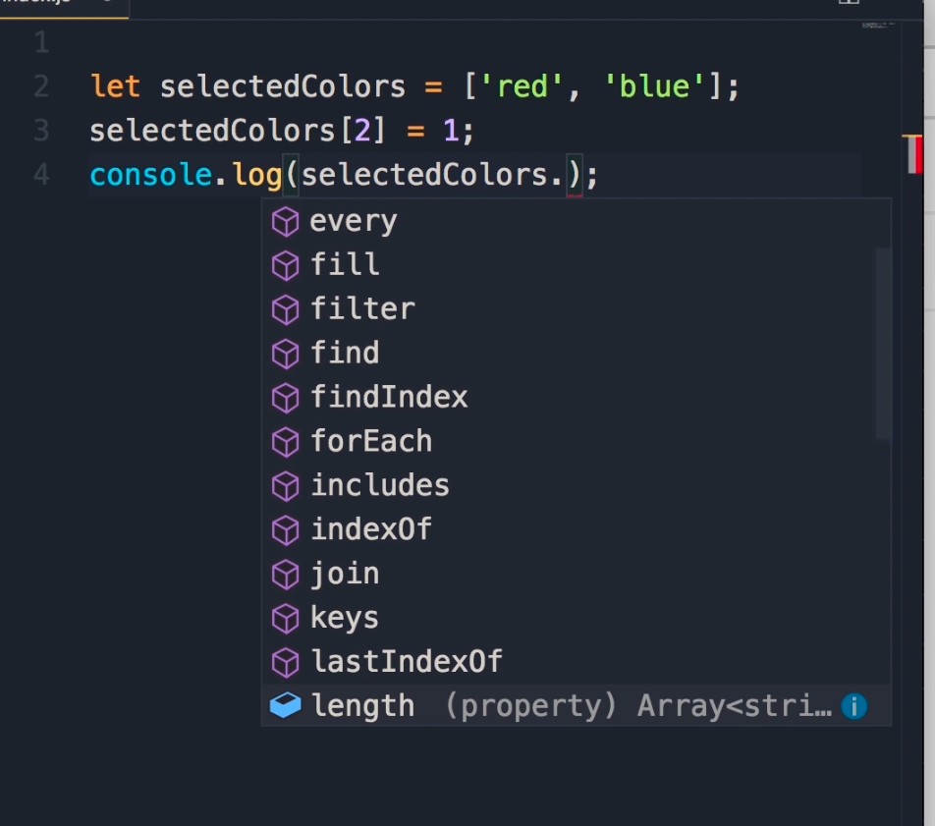

Let’s examine the length property.

let selectedColors = ['red', 'blue'];

selectedColors[2] = '1';

console.log(selectedColors.length);

This property returns the number of items or elements in an array. See below.

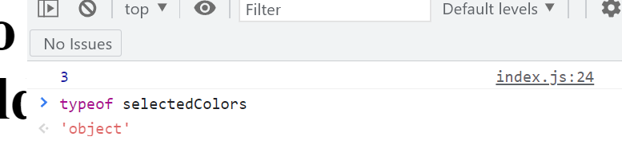

An array is a data structure that we used to represent a list of items.

/*

02 - Basics - 06 - Arrays

let selectedColor = []

The above Square brackets are called a literal array

let selectedColors = ['red', 'blue'];

console.log(selectedColors)

This displays both elements

let selectedColors = ['red', 'blue'];

console.log(selectedColors[0])

This displays the First element.

let selectedColors = ['red', 'blue'];

selectedColors[2] = 'green';

console.log(selectedColors)

This displays a Third element in the array.

*/

let selectedColors = ['red', 'blue'];

selectedColors[2] = '1';

console.log(selectedColors.length);

## 02 - Basics - 07 - Functions

In the category of reference types we’ve learned about objects and arrays.

A function is a set of statements that performs a task or calculates a value.

Let’s declare function using the *function* key word. Let’s give function name, *greet*. Add parenthesis… that’s part of the syntax for declaring functions. () Then {}. What’s inside the curly braces is referred to as the body of the function. This is where we had all the statements to define some kind of logic in our application.

E.g., the logic in this function should be to display a message on the console.

function greet () {

    console.log('Hello World');

}

Note that we terminate our statement with a ;. But when we are declaring a function, we do not need to add a ; at the end, because we’re not declaring it like a variable like this: *let number = 1;*

function greet () {

    console.log('Hello World');

}; this semicolon is unnecessary.

We can call a function like so:

greet();

function greet() {

    console.log('jimbob');

}

greet();

We add the name of the function *greet* with parenthesis *()* and a semicolon to indicate that this is a statement.

**So, in my terms… the function *greet ()* is all one unit, both the word and the parenthesis. Inside {}, we execute the log command. So… all you have to do is add a *greet()* [[with a semicolon]] and you are executing the function by making a statement. So… empty parenthesis are part of the function, along with the name.**

function greet () {

    console.log('Hello World');

}

greet();

((Also, we are mere executing a console log here. Copying and pasting the console log outside the function would give the same value)).

Our function can have inputs, and these inputs can change how the function behaves.

Let’s say we’d like to display the name of a person instead of hello world. We can add a variable in between parentheses. We refer to this variable as a parameter. ^^

function greet(name) {

    console.log('Hello World');

}

greet();

Thus, our greet function has one parameter called name. “essentially name is like a variable that is only meaningful inside of this function. So inside of this function we can work with this name variable but it will not be accessible outside of this function”

[[[I.e., this variable will not contaminate data other code outside the function]]]

Name is an input to this function. So, instead of displaying hello world, we can delete world and add a plus to concatenate two strings… e.g., name:

function greet(name) {

    console.log('Hello' + name);

}

greet();

“When calling the greet function, we need to pass a value for the name variable, or name parameter more accurately”.

[[[When I don’t pass a value for name, the variable is undefined. See below:]]]

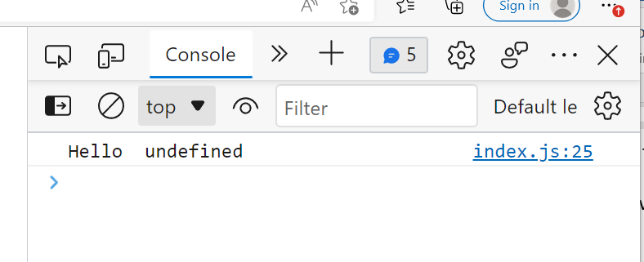

So, we can pass John between the brackets. We refer to this as an argument.

function ***greet (name)*** {

    console.log('Hello' + **name**);

}

greet('John');

“So, John is an argument *to* the greet function. And, name is a parameter *of* the greet function.” ^^ “That’s one of the things that a lot of programmers don’t know. They don’t know the difference between a parameter and an argument.”

[[[I explain function thusly: John is an argument that defines the name variable/parameter. Newly defined name variable/parameter equals **undefined name variable**, which is inside the body of the function]]]

“So a parameter is what we have here at the time of ***declaration***. The argument is the actual value we supply for that parameter.

function ***greet (name) {***

    console.log('Hello' + name);

}

greet('John');

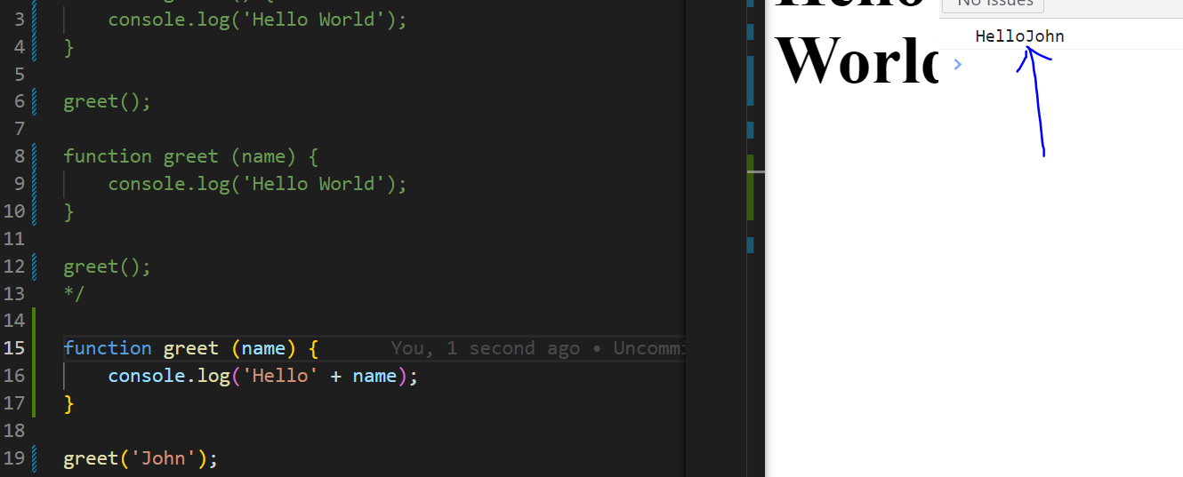

Why does Mosh have a space?

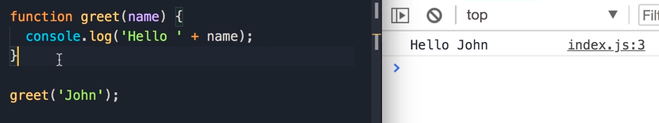

Ah haha. Add a space after hello.

We can reuse this function, with a different input. We can copy the argument line, paste it, and add a name.

function greet (name) {

    console.log('Hello ' + name);

}

greet('John');

greet('Mary');

Now we have two different messages on the console.

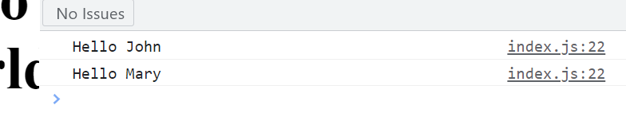

A function can have multiple parameters. We can add more parameters by using a comma. E.g., lastName.

function greet (name, lastName) {

    console.log('Hello ' + name);

}

greet('John');

greet('Mary');

Now we can add this new parameter to console.log. Note that we added an extra space in the quotes. Also, note that parameters aren’t put into quotes. Presumably only the strings? Also, we can easily add spaces to strings, but we cannot do that with parameters. We had to add empty quotes to incorporate spaces.

function greet (name, lastName) {

    console.log('Hello ' + name + ' ' + lastName);

}

greet('John');

greet('Mary');

“when calling this greet function, we should pass another argument for the last name.” Let’s see what happens if we don’t do this.

((I got a different error message previously because last name was not capitalized. Remember that this stuff is case sensitive))

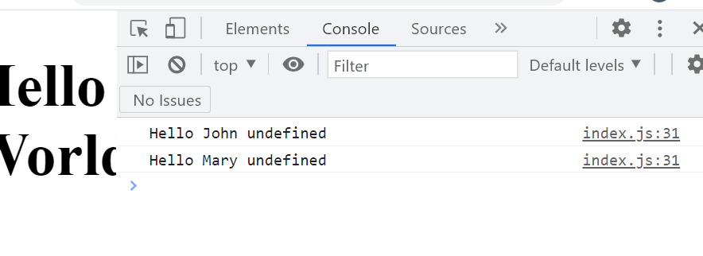

The default value of variables in JavaScript is undefined which is why hello john and hello Mary are undefined. “so because we did not pass a value for the last name, by default it’s undefined.”

For greet, let’s pass another argument. We’ll add a comma, and a last name in quotes. “we don’t need the second call to the greet function”. We’re deleting the second call to the greet to function, which is Mary. ((apparently values are assigned two parameters in consecutive order))

/*

function greet () {

    console.log('Hello World');

}

greet();

function greet (name) {

    console.log('Hello World');

}

greet();

Here we concatenated two strings (hello and name) with a plus, and provided an arguement/function Name

function greet (name) {

    console.log('Hello ' + name);

}

greet('John');

Here we copied our function, and put in a different argument.

function greet (name) {

    console.log('Hello ' + name);

}

greet('John');

greet('Mary');

Here we add a last name, parameter, but we did not pass an argument (assign a value) to it, which is why it is (and displays as) literally 'undefined' in the console.

function greet(name, lastName) {

    console.log('Hello ' + name + ' ' + lastName);

}

greet('John');

greet('Mary');

Lastly, below, we have passed another argument, "Smith", which is assigned to the parameter lastName

*/

function greet(name, lastName) {

    console.log('Hello ' + name + ' ' + lastName);

}

greet('John', 'Smith');

## 02 - Basics - 08 - Types of Functions

Mosh disapproves of all the concatenations listed below. But he says we’ll worry about fixing them later.

console.log('Hello ' + name + ' ' + lastName);

The function below is performing a task. Its task is to display something on the console.

function greet(name, lastName) {

    console.log('Hello ' + name + ' ' + lastName);

}

greet('John', 'Smith');

Let’s do a function that calculates a value.

Let’s create a function and call it square. This function should take a parameter. We’ll call it number.

function square(number) {

}

We want to calculate the square of a given number. Aka, number * number.

function square(number) {

number * number;

}

“we need to return this **value** to whoever is calling this function. For that we use the return key word” We cannot have another variable called return because it is another reserved key word.

function **greet**(name, lastName) {

    console.log('Hello ' + name + ' ' + lastName);

}

function square(number) {

    return **number * number**;

Instead of calling to **greet** function, will call the **square** function.

Square… and we pass 2. [[[*This is a statement* I think]]]

function square(number) {

    return *number* * *number*;

square(2);

((So, the function is like an object, square is the name of the object, (number) is the variable parameter, number*number is the ‘thing/operation’. Return may be a function.))   
[[[No, 2 is an argument to the Square function. It Defines the variable, of the function named Square. Number is a variable/parameter of the Square function. It defines the undefined *number* variable, in the body]]]

We add a square function down below, with the argument (2). The value of 2 initializes a variable, see below.

**So… Order of operations is: variable number equals the function square with the argument 2, which then becomes the function square with the parameter value of 2, which undergoes the function 2*2 before being returned/outputted.**))

“So, squre, we pass two. This returns a value. We can use that value to initialize a variable.”

function square(number) {

return number * number;

}

square(2);

“E.g., we can declare another variable called number, and set it to square of 2.

let number = square(2);

function square(number) {

    return number * number;

}

let number = square(2);

Now we can display this on the console.

console.log(number);

function square(number) {

    return number * number;

}

//We were calling the greet function.  Now we are calling the square function.

let number = square(2);

console.log(number);

[[[Sooo. Console.log log will display Number. But what is Number? Number equals the output of the square function. And the Square Function receives an argument, or we “declare” (*let number*) “a variable” and we “pass a Value” to the Square function. That value is then executed inside the body of the function. I just don’t know if the variable we declare is passing a value, or an argument to the function. ]]]

Soo... we'll call the function Square.  Square has a number parameter.  We will return number times number.

Our variable says that number will equal square function (N times N), with the number parameter being 2.

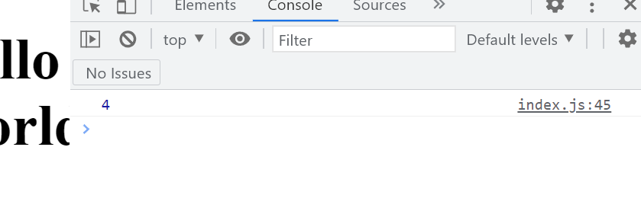

We don’t have to declare a second variable, if all we want to do is display the square of two (square(2)) on the console.

let number = square(2);

console.log(number);

To this:

function square(number) {

    return number * number;

}

console.log(square(2));

**((Here, the log function square has an argument value of 2, which it will pass to the function square with a parameter value of two, which undergoes the function 2X2, and this value will be passed to console.log))**

“So, when the java script engine executes this code, first it will call this function [[square(2)]], it will get a value, and then pass that value to console.log.”



Mosh says we have Two function calls. Square(2) is one function call, and console.log() is Another function call, because it has a parenthesis. ^^ (Function call being the thing that requests info from a function?)

console.log()

We are calling the log function which is defined somewhere and passing an argument ((between the brackets)). We could pass a simple string like hello: *console.log(‘Hello’);* Or we can pass an expression. That expression can be a call to Another function… “like square of 2”: *console.log(square(2));*

“For now, all I want you to take away is that a function is a set of statements that either performs a task for calculates and returns a value.”  
  
/*

This function is Performing a task.

function greet(name, lastName) {

    console.log('Hello ' + name + ' ' + lastName);

}

greet('John', 'Smith');

function square(number) {

    return number * number;

}

//We were calling the greet function.  Now we are calling the square function.

let number = square(2);

console.log(number);

Soo... we'll call the function Square.  Square has a number parameter.  We will return number times number.

Our variable says that number will equal square function (N times N), with the number parameter being 2.  There is an order of operations aspect.  The same term can have different values on the page... because sometimes that term is being acted upon, and other... things are receiving that finished output

function square(number) {

    return number * number;

}

let number = square(2);

console.log(number);

*/

//Performing a task

function greet(name, lastName) {

    console.log('Hello ' + name + ' ' + lastName);

}

function square(number) {

    return number * number;

}

console.log(square(2));

## 03 - Operators - 01 - JavaScript Operators - .40

We utilize operators along with variables and constants to create expressions. With expressions we can implement logic and algorithms.

Kinds of operators:

* Arithmetic operators
* Assignment operators
* Comparison operators
* Logical operators
* Bitwise operators

## 03 - Operators - 02 - Arithmetic Operators

We use arithmetic operators for performing calculations, just like in mathematics. Let’s examine some of them.

We use them for performing calculations, just like in mathematics.   
  
Here’s an example of the addition operator:

let x = 10;

let y = 3;

console.log(x + Y);

Arithmetic operators usually take two operands (like x & y) and then produce a new value.

An expression is something that produces a value. E.g., X + Y.

Comment out - Mosh - 03 - Arithmetic Operators - Highlight a group of text in VSCode and control and slash. It turns text into this:

More Operators:

* // console.log(x + Y);
* // console.log(x - Y);
* // console.log(x * Y);
* // console.log(x / Y);
* // console.log(x % Y); Remainer of division
* // console.log(x ** Y); Exponential? X to the power of Y
* // console.log(x + Y);
* // console.log(x + Y);

Increment operators are indicated by two plus signs (++). Depending on where we put the plus signs this operator will behave differently.

Console.log(x) ((log of X)). “X is initialized to 10” ((Highlights 10 above)).

10 displays on console.

let x = 10;

let y = 3;

console.log(++x);

Displays 11.

This is where things get Weird. If we put this operator After X like so:

let x = 10;

let y = 3;

console.log(x++);

The value of X displays first. And Then the value of X will be incremented by one. So, if we do a Second log:

let x = 10;

let y = 3;

console.log(x++);

console.log(x)

10, Then 11 displays on the console.

/*

let x = 10;

let y = 3;

console.log(x);

Outputs 10

let x = 10;

let y = 3;

console.log(++x);

Outputs 11

let x = 10;

let y = 3;

console.log(x++);

Outputs 10 for the First console, but X Has been incremented by one.

let x = 10;

let y = 3;

console.log(x++);

console.log(x)

Displays 10, and 11 on console, because x is incremented by one after first console.log

Decrement works in the same manner.

*/

let x = 10;

let y = 3;

console.log(x++);

console.log(x)

// console.log(x + Y);

// console.log(x - Y);

// console.log(x * Y);

// console.log(x / Y);

// console.log(x % Y);  Remainer of division

// console.log(x ** Y);  Exponential?  X to the power of Y

// Increment (++)

// Decrement (--)

## 03 - Operators - 03 - Comparison Operators - 2.01

We use comparison operators to compare the value of a variable with something else.

Here we have the x set to 1.

*let x = 1;*

Let’s look at the first comparison operator that is greater than. *console.log(x > 0);*

“So we want to check of X’s greater than zero”

let x = 1;

console.log(x > 0);

The console displays this as true.

“So the result of an expression that includes a comparison operator is a Boolean… It’s true or false”.

console.log(x >= 1);

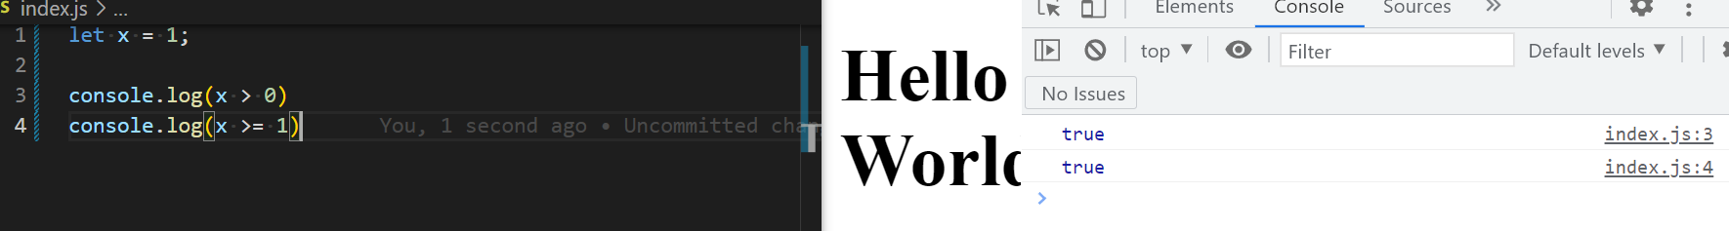

We also have less than, and less than or equal to:

let x = 1;

console.log(x > 0);

console.log(x >= 1);

console.log(x < 1);

console.log(x <= 1);

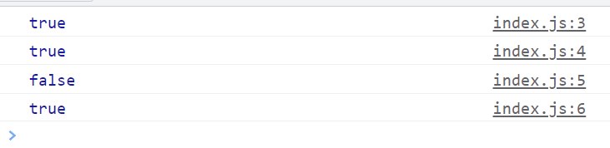

We refer to the above operators as relational operators.

We also have equality operators. We can check and see if X is equal to one:

console.log(x === 1);

If we want to see if x is not equal to a given value, replace the equal sign with an exclamation mark.

((From [MDN](https://developer.mozilla.org/en-US/docs/Web/JavaScript/Reference/Operators/Strict_inequality) - This is a Strict Inequality Operator. “The strict inequality operator ( !== ) **checks whether its two operands are not equal, returning a Boolean result**. Unlike the inequality operator, the strict inequality operator always considers operands of different types to be different.”))

console.log(x !== 1);

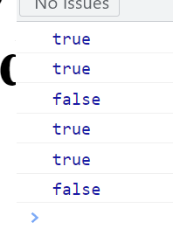

These are all the comparison operators in JavaScript.

let x = 1;

//Relational

console.log(x > 0);

console.log(x >= 1);

console.log(x < 1);

console.log(x <= 1);

//Equality

console.log(x === 1); Is x equal to 1.

console.log(x !== 1); Is x Not equal to 1.

## 03 - Operators - 05 - Equality Operators

Previously we learned about the equality operator. E.g.,

// Strict Equality Operator (Type + Value)

console.log(1 === 1);

In JavaScript we have another equality operator that is indicated by two equals signs.

// Lose Eqaulity Operator

console.log(1 == 1);

The strict equality operator ensures that the values on either side of this operator have the same type and value.

For example on both sides of this operator there are two numbers. Both their type and their value are equal.

console.log(1 === 1);

Suppose we change one of the numbers to a string, like so:

console.log('1' === 1);

This expression is going to evaluate to false. We are comparing a string to a number. The types do not match.

Whereas if we compare a lose equality operator that features a number and a string like so:

// Lose Eqaulity Operator

console.log(1 == 1);

console.log('1' == 1);

The result is still true.

In this case, the operator ((the two equals signs)) looks at the value on the left side, observes that it is a string, and converts the numeral on the right to a string as well.

What if on the left side we have a Boolean?

console.log(true == 1);

The operator will automatically convert the value on the right side to a Boolean.

The console will also read this as true.

“Here’s what you need to take away: the strict equality operator ensures that both values have the same type and the same value. The lose equality operator does not care about the types matching; if the types don’t match it will convert that type on the right side to match the type on the left side. Then, it will only check if the values are equal”

Generally, you will use the strict equality operator because it is more precise and accurate.

/*

// Strict Equality Operator (Type + Value)

console.log(1 === 1);

console.log('1' === 1);

// Lose Eqaulity Operator

console.log(1 == 1);

*/

// Lose Eqaulity Operator

console.log(1 == 1);

console.log('1' == 1);

console.log(true == 1);

## 03 - Operators - 06 - Ternary Operator

Let’s examine the Ternary or conditional operator, which is incidentally one of Mosh’s favorites.

Consider the following problem:

// If a customer has more than 100 points,

// they are a 'gold' customer, otherwise,

// they are a 'silver' customer.

Let’s start by declaring a variable to keep track of the number of points.

let points = 110;

Now let’s declare another variable called type, that will represent the type of customer.

let points = 110;

let type =

Let’s start with a condition. We want to compare the number of points with 100.

So, we use the comparative operator here:

let points = 110;

let type = points > 100

This expression produces a Boolean. The result of this expression is either true or false.

Depending on the result, we’ll set the type variable to a different value. Let’s add a question mark:

*let type = points > 100 ?*

If this expression evaluates to true, that means this is a gold customer… So we want to set type to gold.

let points = 110;

let type = points > 100 ? 'gold' :

If the expression evaluates to false up, we want to set the type to:

let points = 110;

let type = points > 100 ? 'gold' : 'silver';

Let’s log type on the console.

let points = 110;

let type = points > 100 ? 'gold' : 'silver';

console.log(type);

The console displays gold.

let points = 90;

let type = points > 100 ? 'gold' : 'silver';

console.log(type);

Now the console displays silver.

let points = 110;

let type = points > 100 ? 'gold' : 'silver';

console.log(type);

Start with a condition ((using a conditional operator)). If that condition evaluates to true, then the type will receive the value gold. If false, silver.

/*

let points = 110;

let type = points > 100 ? 'gold' : 'silver';

console.log(type);

*/

// If a customer has more than 100 points,

// they are a 'gold' customer, otherwise,

// they are a 'silver' customer.

let points = 90;

let type = points > 100 ? 'gold' : 'silver';

console.log(type);

## 03 - Operators - 07 - Logical Operators - 5.30

We use logical operators to make decisions based on multiple conditions. In JavaScript we have three kinds of logical operators:

* Logical and
* Logical or
* Not

We’ll start with *Logical AND*, which is indicated with two ampersands: &&.

Here is the basic rule of thumb: logical and returns TRUE if both operands are TRUE. Let’s see an example.

console.log(true && true)

We have two operands, and they are both true. So, the result of evaluating this expression will be true.

If either of these are false, the result will be false.

console.log(false && true)

The console outputs false. The console output false if one or both are false.

What is a real world to use case for this operator? Suppose we want to build an application for approving loans. We want to see if the applicant has high income and a good credit score.

Let’s declare a couple variables:

let highincome = true;

let goodCreditScore = true;

Here we are dealing with two conditions. We need to know that the applicant is true for both high income and credit score. That’s where we use the logical And.

Let’s declare another variable:

let eligibleForLoan =

This is where we use the logical and operator:

let eligibleForLoan = highIncome && goodCreditScore;

Now let’s log this on the console:

let eligibleForLoan = highIncome && goodCreditScore;

let highIncome = true;

let goodCreditScore = true;

let eligibleForLoan = highIncome && goodCreditScore;

console.log(eligibleForLoan);

The console outputs true.

Now let’s examine the logical or.

Logical OR is indicated by two vertical lines. This returns true if one or both of the operands are TRUE.

Let’s edit the logical and, and turn it into a logical or, and change one of the operands to false.

let highIncome = false;

let goodCreditScore = true;

let eligibleForLoan = highIncome || goodCreditScore;

console.log(eligibleForLoan);

Lastly, let’s look at the NOT operator. The not operator is indicated by an exclamation mark.

If the applicant is not eligible for loan, we want to consider their application as refused.

Let’s declare another variable:

*let applicationRefused*

Let’s use the NOT operator:

*let applicationRefused = !*

We apply it on eligibleForLoan:

let applicationRefused = !eligibleForLoan;

let highIncome = false;

let goodCreditScore = true;

let eligibleForLoan = highIncome || goodCreditScore;

//NOT (!)

let applicationRefused = !eligibleForLoan;

console.log(eligibleForLoan);

If the eligibleForLoan is true, the not operator will convert that to false. So, whatever we give it, it will give us the opposite. So if eligibleForLoan is true, this will be converted to False, which means applicationRefused will Also be false.

In this scenario, applicationRefused is always the opposite of eligibleForLoan. That’s where we use the not operator.

So… let’s try changing both conditions to False:

let highIncome = false;

let goodCreditScore = false;

let eligibleForLoan = highIncome || goodCreditScore;

console.log(eligibleForLoan);

//NOT (!)

let applicationRefused = !eligibleForLoan;

And… let’s add a label to console.log:

console.log('Eligible', eligibleForLoan);

((When I test this in the console, it gives the result “Eligible false”, instead of just false.))

Let’s do another console.log, and add another label:

//NOT (!)

let applicationRefused = !eligibleForLoan;

console.log('Application Refused')

And we log the applicationRefused variable:

//NOT (!)

let applicationRefused = !eligibleForLoan;

console.log('Application Refused', applicationRefused);

let highIncome = false;

let goodCreditScore = false;

let eligibleForLoan = highIncome || goodCreditScore;

console.log('Eligible', eligibleForLoan);

//NOT (!)

let applicationRefused = !eligibleForLoan;

c

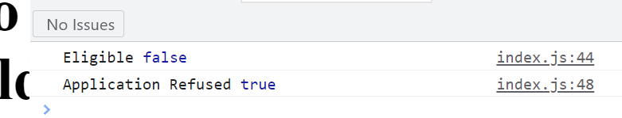

/*

//Logical AND (&&)

//Returns TRUE if both operands are TRUE

console.log(true && true)

We have two operands, and they are both true.  So, the result of evaluating this expression will be true.

console.log(false && true)

The console outputs false.  The console output false if one or both are false.

let highIncome = true;

let goodCreditScore = true;

let eligibleForLoan = highIncome && goodCreditScore;

console.log(eligibleForLoan);

This outputs as true.

// Logical OR (||)

// Returns TRUE if one or both of the operands is TRUE

let highIncome = false;

let goodCreditScore = true;

let eligibleForLoan = highIncome || goodCreditScore;

console.log(eligibleForLoan);

let highIncome = false;

let goodCreditScore = true;

let eligibleForLoan = highIncome || goodCreditScore;

//NOT (!)

let applicationRefused = !eligibleForLoan;

console.log(eligibleForLoan);

This will return the opposite value it receives.  In the above case, the applicant Is eligible for the loan, which means eligibleForLoan returns false, which means applicationRefused is Also false.

*/

// Logical OR (||)

// Returns TRUE if one or both of the operands is TRUE

let highIncome = false;

let goodCreditScore = false;

let eligibleForLoan = highIncome || goodCreditScore;

console.log('Eligible', eligibleForLoan);

//NOT (!)

let applicationRefused = !eligibleForLoan;

console.log('Application Refused', applicationRefused);

/* Basically, when highIncome and goodCreditScore are false, then eligibleForLOad is false.

And the console.log will display the value, along with a label.

If !eligibleforloan has a false input value, it will flip it to true, and applicationRefused will be true.

Console.log will show the label string, and that applicationRefused is True. */

## 03 - Operators - 08 - Logical Operators with Non-booleans - 5.53

In JavaScript unlike many other programming languages we can use logical operators with Non-booleans values.

false or true, aka

false || true

The above is a true expression.

How about:

false || ‘Mosh’

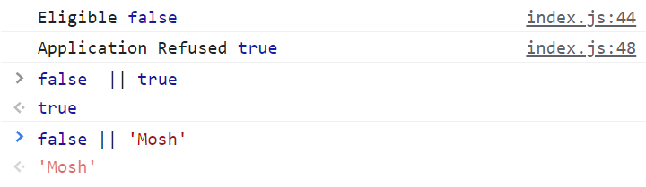

How about:

false || 1

We get an output of 1.

What we realize is that the result of a logical expression is not necessarily true or false. That depends on the value of the operands we have.

In the first example our second operands is true, which is why we get true back.

In our second example, our second Operand is a string, which is why we get a string back.

In the third example our second Operand is a number which is why we get a number back.

So when our JavaScript engine tries to evaluate this expression it looks at each operand. If that operand is not a Boolean true or false, it will try to interpret it as what we call truthy or falsy.

Falsy is not the same as Boolean false.

The values of falsy are:

* Undefined
* Null
* The number zero 0
* Boolean false
* Empty string ‘’
* Not a number NaN groups

Not a number is a special value in JavaScript. Mathematical calculations that do not produce a valid number, this value, not the number, is returned.

If we use any of these Falsy values in a logical expression, they will be treated as Falsy, which is kinda like a Boolean false, but it is not exactly the same.

Anything that is not Falsy, is truthy.

In our second example, our second operand is a string with four characters. ((‘Mosh’)). It’s not an empty string. It’s not falsely. So it’s truthy. Because with the logical/or operator, the result will be true if One of the operands is true. The first operands is false (false || ‘Mosh’), and so the JavaScript engine examines the second operand, which it finds to be not falsy, and therefore truthy.

The same goes for the third example. (false || 1) The 1 is not a Boolean true… It’s truthy. That’s why the value of that operands is returned.

What if we have a triple expression?

false || 1 || 2

The console outputs 1.

With the logical/or operator, it will return a result as soon as it finds an operand that is truthy. The first truthy operand discovered is the one the console will output. You could have a dozen more operands… it will only return the first truthy operand it encounters. This is called Short-Circuiting.

When do we actually use non-Boolean operators?

Suppose we are building an application, and somewhere the user has to pick a color, or were going to use a default color. E.g., the color of the T-shirt they want to buy.

Let’s declare a few variables:

let userColor = 'red';

let defaultColor = 'blue';

let currentColor = userColor || defaultColor;

Let’s log this on the console:

let userColor = 'red';

let defaultColor = 'blue';

let currentColor = userColor || defaultColor;

console.log(currentColor);

The console output is “red”. Because, our user has selected a color.

If the user has not selected a color, then you get the obvious result:

let userColor = undefined;

let defaultColor = 'blue';

let currentColor = userColor || defaultColor;

console.log(currentColor);

Console output is ‘blue’.

“This is the power of using the logical or operator between non-Boolean’s. With this technique we can provide default values.”

/*

Falsy (false) :

Undefined

null

0

boolean false

empty string ''

Not a Number NaN

Anything that is not Falsy -> Truthy

E.g.:

 false || ‘Mosh’

returns: 'Mosh'

false || 1

We get an output of 1.

false || 1 || 2

The console outputs 1.

With the logical/or operator, it will return a result as soon as it finds an operand that is truthy.

You could have a dozen more operands… it will only return the first truthy operand it encounters.  This is called Short-Circuiting.

let userColor = 'red';

let defaultColor = 'blue';

let currentColor = userColor || defaultColor;

console.log(currentColor);

The output is Red, because user color is selected

*/

let userColor = undefined;

let defaultColor = 'blue';

let currentColor = userColor || defaultColor;

console.log(currentColor);

## 03 - Operators - 09 - Bitwise Operator

These operators are more on the theoretical side and not something we'd use on a daily basis. This section of the lecture is for the enthusiasts, a.k.a. autists. ((Mosh encourages us to skip this lesson if we like)).

We humans use the decimal system to represent numbers. “12345”. In computers these numbers are stored in the binary format.

E.g., the number one in the decimal system is represented by seven zeros “00000001”. We have eight digits, each digit is what we call a bit. Above we have eight bits which represent one byte of information.

Number two equals six zeros and then one zero. “00000010”.

“There are mathematical formulas behind these for converting numbers between decimal and binary systems”. If you don’t want to learn the mathematics, simply Google decimal to binary converters.

“Bitwise operators in JavaScript or any other programming languages are similar to logical operators but they work on the individual bits of a number.”

E.g.:

console.log(1 | 2);

Note that we have a single vertical line, that represents a bitwise or. ((1 or 2, 1 | 2)) ((Logical ors have double vertical lines)).

“When we apply the bitwise or between one and two, this is what’s going to happen…”

“I add R as the result here (R =). Now, this operator here is going to look at each of these bits in a vertical way. ((Like adding sums?)). If either of these bits is one, the result will be one. Otherwise it will be zero”

1 = 0000001

2 = 0000010

R = 0000011

“If you convert this binary number (00000011, aka the sum of 0000001 and 00000010) to a decimal number, the result will be three”.

The console displays 3.

Bitwise and is similar. We use a single ampersand instead of a vertical line.

If both numbers are one, one will be returned, otherwise the result will be zero.

1 = 0000001

2 = 0000010

3 = 0000011

R = 0000000

console.log(1 | 2); // Bitwise Or

console.log(1 & 2); // Bitwise And

The console outputs 3 and 0.

Suppose you want to implement an access control system. The user can have the following permissions “Read, Write, Execute”.

We can use one byte of information (or eight bits) to determine the kind permission of a user can have.

E.g., we can use five zeros 00000 (the first 5 bits are irrelevant), for the last three bits, if the user has permission we will use 1, otherwise we will use 0.

E.g., read only permission would look like this: 00000100.

00000100 Read

00000010 Write

00000001 Execute

This is where we use bitwise operators.

Let’s implement an access control system using bitwise operators.

Let’s define a constant called read permission, and set it to a decimal number that is equivalent to a binary number 00000100, i.e. 4.

00000100 Read

00000010 Write

00000001 Execute

const readPermission = 4;

const writePermission = 2;

const executePermission = 1;

Let’s declare a variable like my permission and initially set that to 0.

const readPermission = 4;

const writePermission = 2;

const executePermission = 1;

let myPermission = 0;

Now let’s give ourselves extra permissions.

const readPermission = 4;

const writePermission = 2;

const executePermission = 1;

let myPermission = 0;

myPermission = myPermission | readPermission | writePermission;

((Ah ha. So, my permission equals 0, **OR** it equals readPermission, aka 4, or writePermission, aka 2.

But… what is the point of adding the numbers together? I don’t get it. Ah, if it’s six, that means read and write?))

Let’s log this:

const readPermission = 4;

const writePermission = 2;

const executePermission = 1;

let myPermission = 0;

myPermission = myPermission | readPermission | writePermission;

console.log(myPermission);

6 is our output.

“Technically we don’t care about this decimal number. We can use the bitwise and operator to see if I have a given permission.”

For example:

Let’s declare a variable message.

const readPermission = 4;

const writePermission = 2;

const executePermission = 1;

let myPermission = 0;

myPermission = myPermission | readPermission | writePermission;

let message =

And use the ternary/conditional operator.   
  
*For refreshers:*

let type = points > 100 ? 'gold' :

“We start with a condition”: = **()** ((When working with ternary/conditional operators above, no parenthesis were used. We had a greater than > ))

const readPermission = 4;

const writePermission = 2;

const executePermission = 1;

let myPermission = 0;

myPermission = myPermission | readPermission | writePermission;

let message = ()

“We take myPermission”

*Let message = (myPermission)*

const readPermission = 4;

const writePermission = 2;

const executePermission = 1;

let myPermission = 0;

myPermission = myPermission | readPermission | writePermission;

let message = (myPermission)

“And use the bitwise & operator”

const readPermission = 4;

const writePermission = 2;

const executePermission = 1;

let myPermission = 0;

myPermission = myPermission | readPermission | writePermission;

let message = (myPermission &)

“Along with the readPermission”

const readPermission = 4;

const writePermission = 2;

const executePermission = 1;

let myPermission = 0;

myPermission = myPermission | readPermission | writePermission;

let message = (myPermission & readPermission)

“If this evaluates to true” *let message = (****myPermission & readPermission****)* “that means I have the read permission.”  
  
***((How does any of this evaluate as true or false? If they just aren’t zero? Ah. So, my permission is zero, and read permission can be 0 or 4. If four, then true, and the message displays?))***

“Let’s say we want to display a message like yes:

const readPermission = 4;

const writePermission = 2;

const executePermission = 1;

let myPermission = 0;

myPermission = myPermission | readPermission | writePermission;

let message = (myPermission & readPermission) ? 'yes'

“Otherwise, we want to display no”

const readPermission = 4;

const writePermission = 2;

const executePermission = 1;

let myPermission = 0;

myPermission = myPermission | readPermission | writePermission;

let message = (myPermission & readPermission) ? 'yes': 'no';

“Let me break this up into multiple lines so we can see clearly”

const readPermission = 4;

const writePermission = 2;

const executePermission = 1;

let myPermission = 0;

myPermission = myPermission | readPermission | writePermission;

let message =

(myPermission & readPermission) ? 'yes': 'no';

“Here’s our Ternary Operator” Referring to the bottom half I believe. “We have a condition; if that evaluates to true, this value will be used. Otherwise, this other value will be used”.

“Finally, let’s log this message on the console.

Console.log(message);

const readPermission = 4;

const writePermission = 2;

const executePermission = 1;

let myPermission = 0;

myPermission = myPermission | readPermission | writePermission;

let message =

 (myPermission & readPermission) ? 'yes': 'no';

 console.log(message);

Console outputs: yes

((Interesting. When you remove the yes: no, the console outputs 4. But, when you add that “?” and the yes: no [[gold: silver in the example way above]], it now hinges on the truth of the condition. If it evaluates to true, the first value (yes) will be used. So, perhaps the ? : make it a conditional/ternary… thing))

((If we remove readPermission from the myPermission variable, then the *let message* variable will output as false, and therefore no)).

const readPermission = 4;

const writePermission = 2;

const executePermission = 1;

let myPermission = 0;

myPermission = myPermission | writePermission;

let message =

 (myPermission & readPermission) ? 'yes': 'no';

 console.log(message);

“So, here’s what I want you to take away. With the bitwise or operator we can add permissions. And with the bitwise & operator we can check to see if we have a given permission.”

const readPermission = 4;

const writePermission = 2;

const executePermission = 1;

let myPermission = 0;

myPermission = myPermission | writePermission;

let message =

 (myPermission & readPermission) ? 'yes': 'no';

 console.log(message);

“Of course this is just one real world use case for using the bitwise operators. There are other use cases, but as I told you before they are really not that common. So if this lecture was confusing, don’t worry about it.”

/*

Example of a bitwise or with a single vertical line: console.log(1 | 2);

(Logical ors have double vertical lines ||)

// Bitwise Or  If Either of the bits are 1, the result will be 1.

console.log(1 | 2);

1 = 0000001

2 = 0000010

R = 0000011

// Bitwise And - If both numbers are one, one will be returned.  Otherwise, the result will be zero:

console.log(1 & 2);

1 = 0000001

2 = 0000010

3 = 0000011

R = 0000000

console.log(1 | 2);

console.log(1 & 2);

The console outputs 3 and 0.

These are the fundamentals.

//Read, Write, Exectute  (User features)

//00000 (the first five bits are irrelevant).  The remaining bits indicate that the user has permission if the value is one.

00000100 Read

00000010 Write

00000001

const readPermission = 4;

const writePermission = 2;

const executePermission = 1;

let myPermission =0;

myPermission = myPermission | readPermission | writePermission;

console.log(myPermission);

((console displays 6))

const readPermission = 4;

const writePermission = 2;

const executePermission = 1;

let myPermission = 0;

myPermission = myPermission | readPermission | writePermission;

let message =

 (myPermission & readPermission) ? 'yes': 'no';

 console.log(message);

Outputs to yes

*/

const readPermission = 4;

const writePermission = 2;

const executePermission = 1;

let myPermission = 0;

myPermission = myPermission | writePermission;

let message =

 (myPermission & readPermission) ? 'yes': 'no';

 console.log(message);

## 03 - Operators - 10 - Operators Precedence

Complex expressions require you to consider the precedence of the operators.

E.g.,

let x = 2 + 3 * 4;

Let’s ask the console for the answer:

console.log(x);

14

Of course, the multiplication expression is evaluated before the addition expression.

It is hard to memorize which operators have higher or lower precedence. So when working with complex expressions, you can use parenthesis to determine how these operators are applied. E.g.,

let x = (2 + 3) * 4;

console.log(x);

Now our output is 20.

/*

let x = 2 + 3 * 4;

console.log(x);

The output is 14

let x = (2 + 3) * 4;

console.log(x);

This output is 20.

*/

let x = (2 + 3) * 4;

console.log(x);

## 03 - Operators - 11 - Drill

1 - What is the result of “true && false”?

This statement uses the double ampersand, logical and operator, where the statement is true if both operands are true. Boolean?

Statement is therefore False.

2 - What is the result of “(true && false) || true”?

The Logical and statement is false, and is considered first because it is in parentheses, according to the order of operations. The double vertical lines indicate logical or, where only one of the operands need to be true. The statement is therefore true.

3 - What is the value of y?

Let x = 10;

Let y = (x > 10) ? 1 : 0;

Using the comparison operator, we find that 10 is not greater than 10. The ternary, or conditional operator is indicated by the question mark. If true, I believe the value is 1. If false, 0.

Y = 0.

4 - What is the value of x?  
  
let x = (2 + 3) * (4 + 5);

X = 5*9

X = 45

5 - Which expression returns true?

A - ‘1’ === 1;

B - 1 == 1

C - 1 === 1

The above involve Equality operators. Strict equality operators are indicated by triple equal’s signs ===, and require both the Value And the type to be the same. **A** evaluates as false, as ‘1’ is a string, and a different type.

The Lose Equality Operator requires that the value, but not the type must be the same. It will convert the type on the right to match the left, and then evaluate. **B** evaluates as true, with either operator.

**C** evaluates as true, as both the type and value are the same for a Strict Equality Operator.

6 - What is the value of x?

Let x = (1 == true);

With the Lose Equality Operator, the type on the left is converted to the type on the right, and only then evaluated. Mind you… What numeral is it converted to? Seems to be 1.

So, 1 == true turns into 1 == 1. Which is a True statement. Therefore, x = true.

7 - What is the value of y?

Let x = 10

Let y = (x > 5) && (x < 15);

Let y = (10 > 5) && (10 < 15);

Let y = true && true

Let y = true.

&& indicates Logical &, where the value is true if both operands are true.

8 - What is the value of x?

Let x = 5;

X += 3;

This was not covered in the course. This is an Addition Assignment Operator. It adds the value of the Right operand to a variable, and “assigns the result (of the addition?) to the variable”.

5 += 3 or 5+3=8

X = 8  
  
  
10 - What is the value of y?

Let x = 10;

Let y = x++;

Incremental operators are indicated by two plus signs ++ raise the value of a number by one when assessed Before the number.

When displayed After a number, the increment is only counted when logged a Second time.

So, if this were a double log console.log(x++) and console.log(x), the x would be 11. Instead, it is only 11 in potentia.

X = 10

10 - What is the value of y?

Let x = 1;

Let y = x !==2;

This is not a pairing of the Loose Equality operator and the Logical Not as I thought. This is the Strict Inequality Operator. It checks to see if the operands are not equal, and returns a Boolean. It considers operands of different types to be different.

Y = 1 !==2;

1 is unequal to 2. True.

Y is True

## 03 - Operators - 12 - Swapping Variables

Let’s do a simple programming exercise. Let’s declare two variables:

let a = 'red';

let b = 'blue';

console.log(a)

console.log(b)

We are supposed to add some code to make A post red, and B post blue. I tried this:

let a = 'red';

let b = 'blue';

a = 'blue';

b = 'red';

console.log(a)

console.log(b)

Which works, but is apparently the wrong answer.

Mosh is talking about a 3rd variable. Can we employ logical not?

Huh. We use a third variable as a ‘backup’. Probably, because you’d have a circle if you just tried to make a and b equal each other.

C is assigned the value of A.

A is overwritten by b.

B is overwritten by C.

But the A that is overwritten by b, is Not the b overwritten by C.

let a = 'red';

let b = 'blue';

let c = a;

a = b; //A is overwritten by b

b = c; //C, which has A's value, is overwriting b

console.log(a)

console.log(b)

## 04 - Control Flow - If…else

We’re going to learn how to use expressions and operators along with conditional statements to implement interactivity in our applications.

JavaScript has two kinds of conditional statements:

* if and else - If…else
* switch and case - Switch…case

Suppose we want to get the current hour and depending on its value, we’ll greet the user with a different message.

So if the hour is between 6 AM and 12 PM, we’ll display a “good morning!” message.

If between 12 PM and 6 PM we’ll display good afternoon.

Otherwise we will display good evening.

If our *condition* evaluates to true, the following *statement* will be executed.

if (a **Condition**, which executes statement if true)

statement

(If we have multiple statements put them between curly braces. This creates a block of code).

if (condition) {

    statement

}

We can also have Another condition. If this condition is true, the other statement will be executed.

if (condition) {

    statement

}

else if (anotherCondition)

statement

We can add more curly braces if we want to add more statements.

if (condition) {

    statement

}

else if (anotherCondition) {

    statement

}

As a convention, when we want to define a block of code we put the first curly brace on the same line as displayed above.

if (condition) {

    statement

}

else if (anotherCondition) { //Goes on this line not below

    statement

}

else if (yetAnotherCondition)

statement

If none of the above statements evaluate to true (note we’ve added more else ifs) we can use else to execute one or more other statements.

if (condition) {

    statement

}

else if (anotherCondition) {

    statement

}

else if (yetAnotherCondition)

statement

else

statement

The first statement we want to execute is good morning. We will declare a variable to simulate the time.

let hour = 10;

if (condition) {

    statement

}

else if (anotherCondition) {

    statement

}

else if (yetAnotherCondition)

statement

else

statement

Let’s use 24 hour time format to keep things simple for ourselves.

We are using two comparison operators and two **Expressions**, and applying logical and && in between them. If both of these expressions evaluate to true, then the result of the *full expression* will also be true.

let hour = 10;

if *(****hour >= 6*** *&&* ***hour <  12*** *)* {

    statement

}

else if (anotherCondition) {

    statement

}

else if (yetAnotherCondition)

statement

else

statement

Let’s add the good morning statement, using console.log.

let hour = 10;

if (hour >= 6 && hour <  12 ) {

    console.log('Good morning');

}

else if (anotherCondition) {

    statement

}

else if (yetAnotherCondition)

statement

else

statement

Mosh suggested finishing on our own. So, I came up with two solutions to the problem of 6PM to 12AM, and 12 AM to 6 AM being in the same statement. So, I could either use a Logical Or ||, or just make two consoles. Let’s test it.

let hour =  22;

if (hour >= 6 && hour < 12 ) {

    console.log('Good morning');

}

else if (hour >= 12 && hour < 18) {

    console.log('Good Afternoon!');

}

else if ((hour >= 18 && hour < 24) || (hour > 0 && hour < 6)) {

console.log('Good Evening!');

}

Works fine.

Let’s try splitting up the statement. This also works:

let hour =  4;

if (hour >= 6 && hour < 12 ) {

    console.log('Good morning');

}

else if (hour >= 12 && hour < 18) {

    console.log('Good Afternoon!');

}

else if (hour >= 18 && hour < 24) {

console.log('Good Evening!');

}

else if (hour > 0 && hour < 6) {

    console.log('Good Evening!');

    }

But Both are wrong!

Apparently else covers everything else.

let hour = 4;

if (hour >= 6 && hour < 12 ) {

    console.log('Good morning');

}

else if (hour >= 12 && hour < 18) {

    console.log('Good Afternoon!');

else

console.log('Good evening');

Mosh says to get rid of the brackets, because there aren’t Multiple statements inside the brackets.

let hour =  4;

if (hour >= 6 && hour < 12 )

    console.log('Good morning');

else if (hour >= 12 && hour < 18)

    console.log('Good Afternoon!');

else

console.log('Good evening');

/*

Ff the hour is between 6 AM and 12 PM, we’ll display a “Good morning!” message.

If between 12 PM and 6 PM we’ll display Good afternoon!

Otherwise we will display Good evening!

let hour =  22;

if (hour >= 6 && hour < 12 ) {

    console.log('Good morning');

}

else if (hour >= 12 && hour < 18) {

    console.log('Good Afternoon!');

}

else if ((hour >= 18 && hour < 24) || (hour > 0 && hour < 6)) {

console.log('Good Evening!');

}

Works fine.  Let’s try splitting up the statement.

This also works:

let hour =  4;

if (hour >= 6 && hour < 12 ) {

    console.log('Good morning');

}

else if (hour >= 12 && hour < 18) {

    console.log('Good Afternoon!');

}

else if (hour >= 18 && hour < 24) {

console.log('Good Evening!');

}

else if (hour > 0 && hour < 6) {

    console.log('Good Evening!');

    }

let hour =  4;

if (hour >= 6 && hour < 12 ) {

    console.log('Good morning');

}

else if (hour >= 12 && hour < 18) {

    console.log('Good Afternoon!');

}

else

console.log('Good evening');

*/

//Mosh says get rid of ugly brackets.

let hour =  4;

if (hour >= 6 && hour < 12 )

    console.log('Good morning');

else if (hour >= 12 && hour < 18)

    console.log('Good Afternoon!');

else

console.log('Good evening');

## 04 - Control Flow - 02 Switch…Case

Let’s declare a variable called role. We’ll imagine that this represents the role of the current user

let role;

Suppose we want to determine the role of the current user i.e. guest, moderator, or an admin. We could implement this logic using *if and else* statements, but there’s another way. Switch and case.

Start with a switch statement:

switch

Now let’s add a variable (role) instead of condition:

switch (role) {

}

Now let’s add one or more **case statements**. Case statements compare the value of the variable with ‘something’.

Here’s our first case. [[I.e., case (in switch in case) means, “Switch means X. In that case, do Y”]]

let role;

switch (role) {

case

}

If this role equals guest:

let role;

switch (role) {

case 'guest'

}

(We are comparing the value of role with guest).

Then we add a colon and one or more statements.

let role;

switch (role) {

case 'guest':

    console.log('Guest');

}

Now we need to add the break statement, to jump us out of this switch block… Otherwise the other statements ‘below’ will be executed.

let role;

switch (role) {

case 'guest':

    console.log('Guest');

break;

}

E.g. let’s add another case statement. If this user is a moderator, we want to display on console.log ‘moderator user’. Then add a break.

let role;

switch (role) {

case 'guest':

    console.log('Guest');

break;

case 'moderator':

    console.log('Moderator User');

    break;

}

So, if we don’t add the first break statement above, and the role equals guest, both the console.log statements will be executed. Adding a break allows us to jump out of the switch block.

let role;

switch (role) {

case 'guest':

    console.log('Guest');

break;

case 'moderator':

    console.log('Moderator User');

    break;

    default:

        console.log('Unknown User');

}

If none of these cases are matched, we can have a default statement. We can use it to execute one or more statements. Like console.log unknown user.

We don’t need a break for the default statement “because at this point the control would automatically get out of the switch block”.

The console is outputting unknown user because we have not initialized *role* and its default value is undefined, and it doesn’t match any of our case statements.

let role;

switch (role) {

case 'guest':

    console.log('Guest User');

break;

case 'moderator':

    console.log('Moderator User');

    break;

    default:

        console.log('Unknown User');

}

Whereas, if we define role, we will output guest.

let role; ‘guest’;

switch (role) {

case 'guest':

    console.log('Guest User');

break;

case 'moderator':

    console.log('Moderator User');

    break;

    default:

        console.log('Unknown User');

}

With switch in case, we can compare the value of a variable against multiple other values. They don’t have to be strings, they can be numbers or even Boolean’s… though using Boolean’s here is less common… Because if you want to compare the value of a variable with true and false it makes more sense to use an if statement.

We can also implement this exact logic using if and else statements.

if (role === 'guest') console.log('Guest User');

else if (role === 'moderator') console.log('Moderator User');

else console.log('Unknown User');

Note that the if and else implementation is cleaner and shorter. We don’t have the break statements or default or the curly braces. Some people still use switch and case though they are somewhat outdated. “And look a little bit ugly in my personal opinion.” However, sometimes they are more explicit and it comes down to your own personal preference.

/*

Suppose we want to determine the role of the current user i.e. guest, moderator, or an admin.

let role;

switch (role) {

case 'guest':

    console.log('Guest');

break;

case 'moderator':

    console.log('Moderator User');

    break;

    default:

        console.log('Unknown User');

The console is outputting unknown user because we have not initialized role and its default value is undefined, and it doesn’t match any of our case statements.

*/

let role = 'guest';

switch (role) {

case 'guest':

    console.log('Guest User');

break;

case 'moderator':

    console.log('Moderator User');

    break;

    default:

        console.log('Unknown User');

}

//We can also implement this exact logic using if and else statements.

if (role === 'guest') console.log('Guest User');

else if (role === 'moderator') console.log('Moderator User');

else console.log('Unknown User');

## 04 - Control Flow - 03 - For

Suppose we wanted to repeat an action a number of times. For example, we might wish to say hello world five times. Don’t do it like this:

console.log('Hello World');

console.log('Hello World');

console.log('Hello World');

console.log('Hello World');

console.log('Hello World');

To achieve a better result, use loops. Loops repeat an action a number of times.

Loops:

* For
* While
* Do…while
* For…in
* For…of

These loops all do basically the same thing. But there are subtle differences between how they start and end.

Let’s examine the for loop first.

Now we need three statements. The first statement is the initialExpression.

for (initialExpression)

Here we declare and initialize a variable. We use *let* to declare the variable *i*, and set it to *zero*.

for (let i = 0)

I is short for index and is a common convention to use in for loops. This is what we call the loop variable.

After initializing this to zero, we terminate the statement with a semicolon.

for (let i = 0;)

The second part of the for loop is what we call a **condition**.

for (let i = 0; condition)

Here we want to add a condition and compare the value of i with something else. This loop will run as long as is condition evaluates to true.

So, if we want the loop to run five times, we’d compare I with five.

for (let i = 0; i < 5; )

The third part is what we call incrementExpression. Often times will use the increment operator like so, to increment the value of I with one.

for (let i = 0; i < 5; i++)

After this *for* statement, we can add one or more statements. (If you have multiple statements you need to put them in a curly braces code block).

for (let i = 0; i < 5; i++) {

    console.log ('Hello World');

}

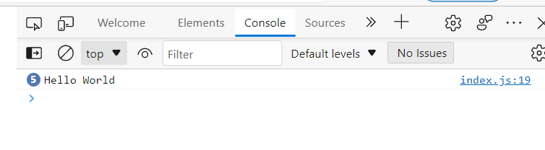

So, how does this all work?

As mentioned before, this is what we call an Initial Expression. We are initializing I to 0. ((I has a value of zero)).

for (let i = 0; i < 5; i++) {

    console.log ('Hello World');

}

This loop will execute

for (let i = 0; i < 5; i++) {

    console.log ('Hello World');

}

so long as this condition is true:

for (let i = 0; i < 5; i++) {

    console.log ('Hello World');

}

As long as I is less than five, the log statements will be executed.

After the first iteration, i is incremented by one. Then the i < 5 condition is evaluated again, and one is less than five.

After the second iteration, i is incremented by one, and now were in the third iteration.

To see this in action, let’s output on the console:

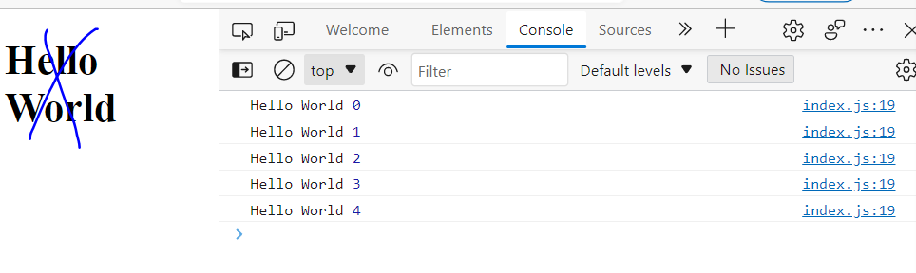

At the end of the fifth iteration, i will four, and when we increment that by one I will be five, and the condition will evaluate to false.

So, there are two ways to repeat an action using the for loop. We can initialize I to zero and check to see if it’s less than five.

Alternately, I to 1, and see if it is less than or equal to five.

for (let i = 1; i <= 5; i++) {

    console.log ('Hello World', i);

}

((Note that we are displaying 1 to 5 instead of 0 to 4))

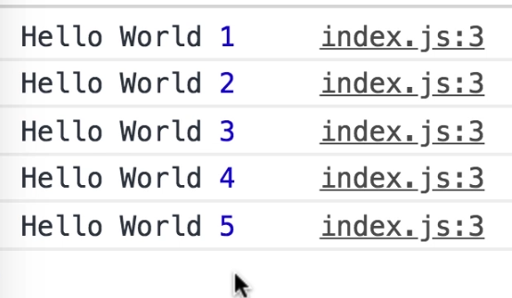

Suppose we only wanted to display the odd numbers between 1 to 5.

We can make an *if* statement check the remainder of the division of I by two.

for (let i = 1; i <= 5; i++) {

if (i % 2 !== 0)

}

((Even numbers Don’t have remainders… i.e., they equal zero)).

So, if the remainder of the division of I by two is not zero, that means I is an odd number.

Let’s displayed on the console.

for (let i = 1; i <= 5; i++) {

if (i % 2 !== 0)

}

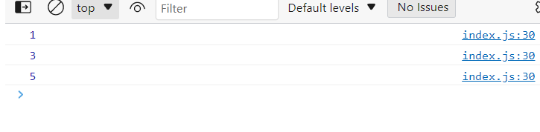

We can also work backwards; instead of going from 1 to 5, we can go from 5 to 1.

for (let i = 5; i >= 1; i--) {

   if (i % 2 !== 0) console.log(i);

}

This outputs odd number in the reverse order.

The previous form is more common… initializing I to zero or 1. But for certain problems, you want to use the for loop in the reverse order.

/*

console.log('Hello World');

console.log('Hello World');

console.log('Hello World');

console.log('Hello World');

console.log('Hello World');

Don't be dumb.

this is how you do it.

for (let i = 0; i < 5; i++) {

    console.log ('Hello World');

}

note the value of the statement displayed on conosole

for (let i = 0; i < 5; i++) {

    console.log ('Hello World', i);

}

We can start i witha value of 1

for (let i = 1; i <= 5; i++) {

    console.log ('Hello World', i);

}

*/

for (let i = 5; i >= 1; i--) {

   if (i % 2 !== 0) console.log(i);

}

## 04 - Flow Control - 04 - While

Loops:

* For
* While
* Do…while
* For…in
* For…of

In the previous lecture we wrote this for loop to display all odd numbers between zero and five.

for (let i = 0; i <= 5; i++) {

    if (i % 2 !== 0) console.log(i);

}

Let’s do the same thing with the while loop.

In for loops, the loop variable is part of the loop itself.

for (let i = 0; i <= 5; i++) {

    if (i % 2 !== 0) console.log(i);

}

In while loops, we have to declare this variable externally.

Let’s declare a variable like i, and set it to zero:

*//for (let i = 0; i <= 5; i++) {*

*//    if (i % 2 !== 0) console.log(i);*

*//}*

let i = 0;

With the for loop, the variable was only meaningful and accessible inside the for loop. It’s called **scope**. “These two variables are completely different, even though they are named the same.”

//for (let i = 0; i <= 5; i++) {

//    if (i % 2 !== 0) console.log(i);

}

let i = 0;

Now let’s add a while statement, and in parenthesis will add our condition. Our condition is that I is less than or equal to five.

let i = 0;

while (i <= 5)

Next will add our statements.

let i = 0;

while (i <= 5) {

if (i % 2 !== 0) console.log(i);

}

Lastly, at the end of our while block we need to increment i.

let i = 0;

while (i <= 5) {

if (i % 2 !== 0) console.log(i);

i++;

}

This is a direct translation from a for loop into a while loop.

for (let i = 0; i <= 5; i++) {

    if (i % 2 !== 0) console.log(i);

}

let i = 0;

while (i <= 5) {

if (i % 2 !== 0) console.log(i);

i++;

}

Let’s review the code below. Initially, I is zero.

In the why loop, first this condition is evaluated. If this condition is true, then the body of the while loop will be executed.

In the next iteration the condition is evaluated again. If true, the statements in the while block will be executed, otherwise the while block will terminate.

for (let i = 0; i <= 5; i++) {

    if (i % 2 !== 0) console.log(i);

}

let i = 0;

while (i <= 5) {

if (i % 2 !== 0) console.log(i);

i++;

}

for (let i = 0; i <= 5; i++) {

    if (i % 2 !== 0) console.log(i);

}

let i = 0;

while (i <= 5) {

if (i % 2 !== 0) console.log(i);

i++;

}

((Also, This does not work. Not sure why:

let i = 0;

while (i <= 5; i++;) {

if (i % 2 !== 0) console.log(i);

}

))

## 04 - Control Flow - 05 - Do…While

Loops:

* For
* While
* Do…while
* For…in
* For…of

Let’s rewrite this as a do…while loop.

for (let i = 0; i <= 5; i++) {

    if (i % 2 !== 0) console.log(i);

}

let i = 0;

while (i <= 5) {

if (i % 2 !== 0) console.log(i);

i++;

}

let i = 0;

Mosh points out that i has already been declared in this document as part of the while loop. It is *not* incompatible with i in the for loop as that is… contained.

for (let i = 0; i <= 5; i++) {

    if (i % 2 !== 0) console.log(i);

}

let i = 0;

while (i <= 5) {

if (i % 2 !== 0) console.log(i);

i++;

}

let i = 0;

So we comment out those lines pressing control/.

for (let i = 0; i <= 5; i++) {

    if (i % 2 !== 0) console.log(i);

}

//let i = 0;

//while (i <= 5) {

//if (i % 2 !== 0) console.log(i);

//i++;

//}

let i = 0;

Let’s rewrite the logic above.

Like while loops, we have to declare our loop variable externally. We declare i and initialize it to zero.

Now we add the “do statement” and a code block.

for (let i = 0; i <= 5; i++) {

    if (i % 2 !== 0) console.log(i);

}

//let i = 0;

//while (i <= 5) {

//if (i % 2 !== 0) console.log(i);

//i++;

//}

let i = 0;

do {

}

In this block we should have our statements. Let’s copy them from the while loop.

*for (let i = 0; i <= 5; i++) {*

*if (i % 2 !== 0) console.log(i);*

*}*

*//let i = 0;*

*//while (i <= 5) {*

*//if (i % 2 !== 0) console.log(i);*

*//i++;*

*//}*

let i = 0;

do {

    if (i % 2 !== 0) console.log(i);

     i++;

}

At the end of this block, we add the while statement, along with our condition in parentheses. That’s I less than or equal to five.

*for (let i = 0; i <= 5; i++) {*

*if (i % 2 !== 0) console.log(i);*

*}*

*//let i = 0;*

*//while (i <= 5) {*

*//if (i % 2 !== 0) console.log(i);*

*//i++;*

*//}*

let i = 0;

do {

    if (i % 2 !== 0) console.log(i);

     i++;

} while (i <= 5);

What is the difference between a while loop and a do while loop?

let i = 0;

while (i <= 5) {

if (i % 2 !== 0) console.log(i);

i++;

}

let i = 0;

do {

    if (i % 2 !== 0) console.log(i);

     i++;

} while **(i <= 5)**;

Do while loops are always executed at least once even if this **condition** is evaluated to false.

Let’s examine our old while loop.

let i = 0;

while (i <= 5) {

if (i % 2 !== 0) console.log(i);

i++;

}

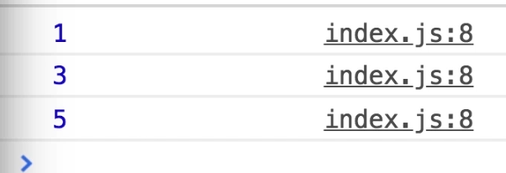

If we were to let i equal nine, with the old while loop…

let i = 9;

while (i <= 5) {

if (i % 2 !== 0) console.log(i);

i++;

}

the console will display nothing. Because the first time we try to execute the while loop, this condition evaluates to false. The following statements are never executed. So, in while loops this condition is evaluated before the following code block, at the beginning of *every iteration*.

Whereas in do while loops

let i = 0;

do {

    if (i % 2 !== 0) console.log(i);

     i++;

} while (i <= 5);

this condition is evaluated at the end. Thus, the middle statements are always executed at least once, even if the while condition is false.

So, if we set this while loop to nine, we get nine on the console.

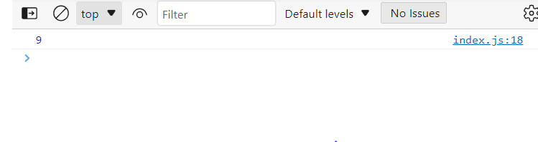

“Realistically you’re not going to use this do while a lot in programming. There are situations in which you may want to use this, but in practical terms most of the time you’ll be using a four or a while loop. Just be aware of the difference between a while loop and a do while loop. ”

The// for (let i = 0; i <= 5; i++) {

//     if (i % 2 !== 0) console.log(i);

// }

// let i = 9;

// while (i <= 5) {

// if (i % 2 !== 0) console.log(i);

// i++;

// }

let i = 9;

do {

    if (i % 2 !== 0) console.log(i);

     i++;

} while (i <= 5);

## 04 - Control Flow - 06 - Infinite Loops

Loops:

* For
* While
* Do…while
* For…in
* For…of

An infinite loop executes infinitely. If you create one of these loops, you will crash your browser or your computer.

Let’s declare a variable and set it to zero. We’ll put it in a while loop, where I is less than five, and then console.log.

let i = 0;

while(i < 5) {

    console.log(i);

}

If we forget the increment I (i++), we end up creating an infinite loop.

In the first iteration by zero and is less than five, so we will display i on the console. In all the subsequent iterations I will still be zero.

This log ran up on the console the 6500 times before freezing.

Another example of an infinite loop:

while (true) {

}

You can also create an infinite do while loop.

do {

} while (true);

Or another, where we fail to increment x:

let x = 0;

do {

***// x++;***

} while (x < 5);

We can also create an infinite for loop.

for (let i = 0; i > 0: i++)

or

for (let i = 0; i < 10; )

## 04 - Control Flow - 07 - For…in

Loops:

* For
* While
* Do…while
* For…in
* For…of

With the first three loops we can repeat an action a number of times. We use the other kind of loops to “iterate over the properties of an object or elements of an array”.

Iterate: perform or utter repeatedly. "the bird's call is a monotonously iterated single note"

Suppose we have an object called person with two properties: name and age:

const person = {

    name: 'Mosh',

age: 30

};

Suppose we want to display all the properties of this person object. That’s when we use the *for-in* loop.

Unlike the *for loop*, we **don’t** have an initial expression; a condition; and in increment)

*for (initialExpression; condition; increment)*

const person = {

    name: 'Mosh',

age: 30

};

for (initialExpression; condition; increment)

let key in person:

const person = {

    name: 'Mosh',

age: 30

};

for (let key in person)

So, in every iteration the key variable in the loop will hold the name of one of the properties in this person object. [[[I.e., the key variable will ***represent***one of the properties of the object. So, in the first iteration it displays name, in the second iteration, it displays the age, etc. Note, that person is the ‘variable’? that key is connected to]]]

Let’s add a console.log of the key variable.

const person = {

    name: 'Mosh',

age: 30

};

for (let key in person)

console.log(key);

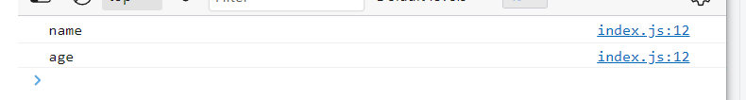

In the first iteration key is name, in the second-generation key is age.

Suppose we wanted to display the value of each property next to it?

const person = {

    name: 'Mosh',

age: 30

};

for (let key in person)

console.log(key);

To access the properties of an object we could use dot notation:

person.name

const person = {

    name: 'Mosh',

age: 30

};

for (let key in person)

console.log(key);

person.name

Or, we could utilize bracket notation. Person, square brackets, and the name of the target property as a string.

const person = {

    name: 'Mosh',

age: 30

};

for (let key in person)

console.log(key);

person.name

person ['name']

We use the bracket notation when we don’t know ahead of time at the time of writing code what property we are going to access. The name of the target property might be calculated at run time. [[Does this mean with multiple iterations, you don’t know Which property of the object will be retrieved?]]]

E.g. “When we **iterate over** [[iterate *through*, one after another,might be a better way of putting it]] the properties of the person object, in each **iteration**, the value of key is going to be different.”

const person = {

    name: 'Mosh',

age: 30

};

**for (let key in person)**

console.log(key);

person.name

person ['name']

So here we can’t ((I think Mosh says *can’t*)) use the dot notation to display the value of this property. I.e., “we can’t do something like this”:

const person = {

    name: 'Mosh',

age: 30

};

for (let key in person)

console.log(key, person.key);

person.name

person ['name']

“because we don’t have a property called key in the person object”. [[Key refers to the Object person, not to the Properties of person.]]

So that’s when we use the bracket notation. So, we add square brackets and pass key as the name of the target property (as a ‘string’). [[So, instead of saying Name or Age, we use ‘pass’ or pretend that Key is the target property]]

const person = {

    name: 'Mosh',

age: 30

};

for (let key in person)

console.log(key, person[key]);

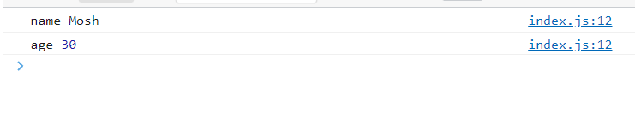

This is the for in loop. We use it to iterate over [[through]] the properties of an object. We can also use these to iterate over [[through]] an array, but it’s not the ideal way. Let’s see an example anyway.

Let’s define an array called colors.

const colors = ['red', 'green', 'blue'];

const person = {

    name: 'Mosh',

age: 30

};

for (let key in person)

console.log(key, person[key]);

const colors = ['red', 'green', 'blue'];

Now let’s use the for..in loop to iterate over [[go through]] this array.

for (let index in colors)

const person = {

    name: 'Mosh',

age: 30

};

for (let key in person)

console.log(key, person[key]);

const colors = ['red', **'green'**, **'blue'**];

for (let index in colors)

We named the loop variable *index* because in each iteration, the index variable will be set to the index to one of the elements in this array. So, it’s going to be zero, **one** and **two**.

Let’s have a look, using console.log:

console.log(index);

const person = {

    name: 'Mosh',

age: 30

};

for (let key in person)

console.log(key, person[key]);

const colors = ['red', 'green', 'blue'];

for (let index in colors)

console.log(index);

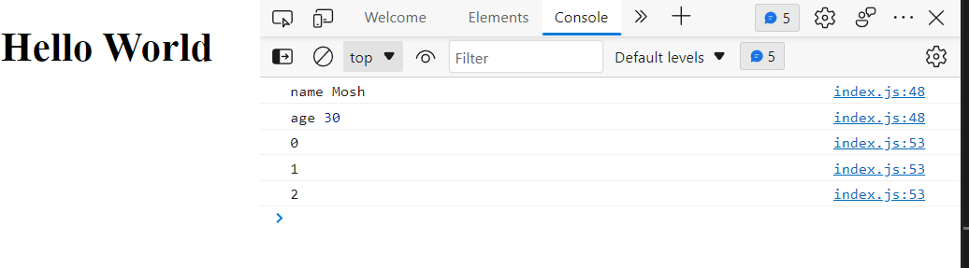

If you want the ***element*** at the given index, once again, we use the square bracket notation. Colors of index:

console.log(index, colors[index]);

const person = {

    name: 'Mosh',

age: 30

};

for (let key in person)

console.log(key, person[key]);

const colors = ['red', 'green', 'blue'];

for (let index in colors)

console.log(index, colors[index]);

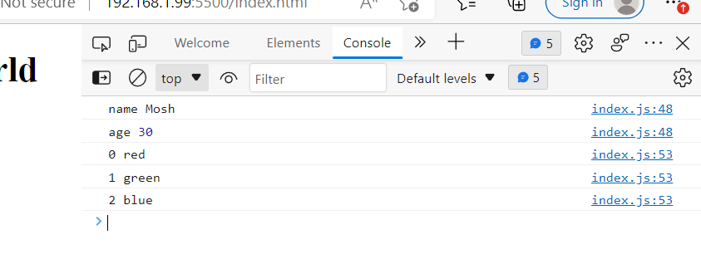

Now we can see each element of our colors array.

Starting from ecma script 6, or es6, which is the modern version of javascript, we have a new kind of loop, called for-of loop. This is the ideal way to iterate over [[through]] arrays.

/*

const person = {

    name: 'Mosh',

age: 30

};

for (let key in person)

console.log(key);

//this displays "name" and then "age" in the second iteration

const person = {

    name: 'Mosh',

age: 30

};

for (let key in person)

console.log(key, person.key);

//dot notation ((e.g., person.key)) does not work.  There is no property called key in //the person object.

const person = {

    name: 'Mosh',

age: 30

};

for (let key in person)

console.log(key, person[key]);

//this 'passes' key as the name of the target property.  I think this means key stands in for or pretends to be the property of the person object, and it runs/iterates through them.  Now both the property, And the property's value is displayed.

*/

const person = {

    name: 'Mosh',

age: 30

};

for (let key in person)

console.log(key, person[key]);

const colors = ['red', 'green', 'blue'];

for (let index in colors)

console.log(index, colors[index]);

//with console.log(index), the numerical values, i.e., the index varialbe is set to the index of one of the elements in the array... will be displayed.  Whereas, when colors[index] is included, the Element at a given index will be displayed

## 04 - Control Flow - 08 - For…of

Starting from ecma script 6, or es6, which is the modern version of javascript, we have a new kind of loop, called *for-of* loop. This is the ideal way to iterate over [[through]] arrays.

The for-of is very similar to the for-in loop but instead of the in keyword, we use the *of* keyword.

for (let index in colors)

const person = {

    name: 'Mosh',

age: 30

};

for (let key in person)

console.log(key, person[key]);

const colors = ['red', 'green', 'blue'];

for (let index in colors)

console.log(index, colors[index]);

E.g.,

for (let color of colors);

const person = {

    name: 'Mosh',

age: 30

};

for (let key in person)

console.log(key, person[key]);

const colors = ['red', 'green', 'blue'];

for (let index in colors)

console.log(index, colors[index]);

for (let color of colors);

Now we can simply log this color on the console:

console.log(color);

const person = {

    name: 'Mosh',

age: 30

};

for (let key in person)

console.log(key, person[key]);

const colors = ['red', 'green', 'blue'];

for (let index in colors)

console.log(index, **colors[index])**;

for (let color of colors)

console.log(color);

With this new four-loop, we don’t have to deal with this (above) index. And we don’t have to access the element at the **given index.**  So in each iteration, this color, which is our loop variable will hold one of the items in this array.

((Zack. Hence, we are utilizing the color variable, rather than the value of the index.))

Suppose we have an object called person with two properties: name and age:

const person = {

    name: 'Mosh',

age: 30

};

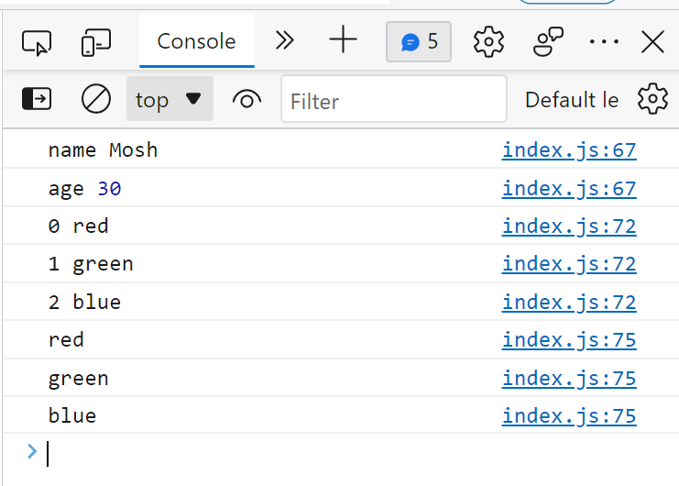

To summarize:

We use the for-in loop to iterate over the properties of an object.

And the for-of loop to iterate over the elements, or items in an array.

//for-in

const person = {

    name: 'Mosh',

age: 30

};

for (let key in person)

console.log(key, person[key]);

//for-of

const colors = ['red', 'green', 'blue'];

for (let color of colors)

console.log(color);

/*

const person = {

    name: 'Mosh',

age: 30

};

for (let key in person)

console.log(key, person[key]);

const colors = ['red', 'green', 'blue'];

for (let index in colors)

console.log(index, colors[index]);

for (let color of colors)

console.log(color);

//with the for of loop, the color variable will 'hold' an item in the array as it iterates through.  It won't also display the index number, like with you use a for-in loop.

*/

//for-in

const person = {

    name: 'Mosh',

age: 30

};

for (let key in person)

console.log(key, person[key]);

//for-of

const colors = ['red', 'green', 'blue'];

for (let color of colors)

console.log(color);

//We use the for-in loop to iterate over the properties of an object.

//And the for-of loop to iterate over the elements, or items in an array.

## 04 - Control Flow - 09 - Break and Continue

With all the loops we’ve learned about in this section, the two keywords break and continue they can change how the loop behaves.

Let’s use a while loop as an example.

Let’s declare a variable:

let

We’ll call it i:

let i

And *initialize* to zero:

let i *= 0;*

Now will put this in a while loop:

while (i <= 10)

let i = 0;

while (i <= 10)

And display I on the console:

console.log(i);

let i = 0;

while (i <= 10) {

    console.log(i);  
}

And increment it:

 i++;

let i = 0;

while (i <= 10) {

    console.log(i);

    i++;

}

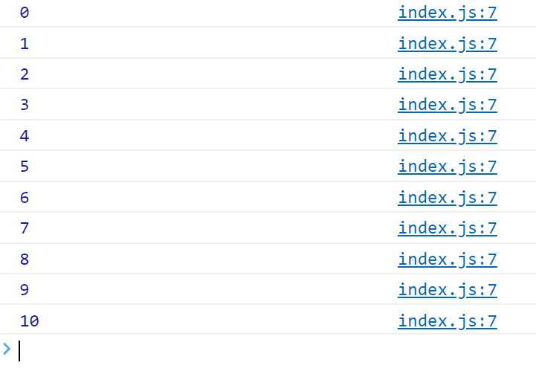

Sometimes, you want to jump out of a loop for some reason that may happen at runtime.

E.g., an *if* condition

if

let i = 0;

while (i <= 10) {

    if

    console.log(i);

    i++;

}

And an if statement ()

  if ()

let i = 0;

while (i <= 10) {

    if ()

    console.log(i);

    i++;

}

If i = 5…

 if (i === 5)

let i = 0;

while (i <= 10) {

    if (i === 5)

    console.log(i);

    i++;

}

…we want to jump out of the loop.

This is where we use the *break* keyword.

 if (i === 5) break

let i = 0;

while (i <= 10) {

    if (i === 5) break

    console.log(i);

    i++;

}

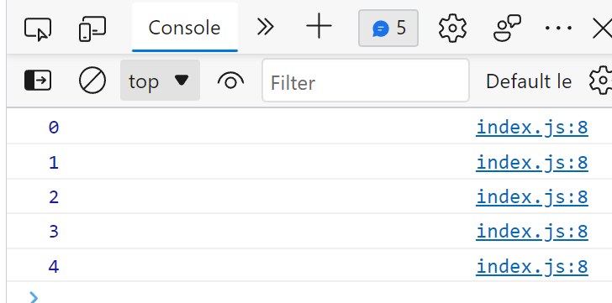

Now let’s examine the continue keyword. Let’s write a new *if* statement.

If i is an even number. i, modulus 2 equals zero. (Modulus is another term for Absolute Value).

If (i % 2 === 0)

 if (i % 2 === 0)

let i = 0;

while (i <= 10) {

   // if (i === 5) break

   if (i % 2 === 0)

    console.log(i);

    i++;

}

If so, increment I, and continue:

if (i % 2 === 0) {

    i++;

    continue;

let i = 0;

while (i <= 10) {

   // if (i === 5) break

   if (i % 2 === 0) {

    i++;

    continue;

   }

    console.log(i);

    i++;

}

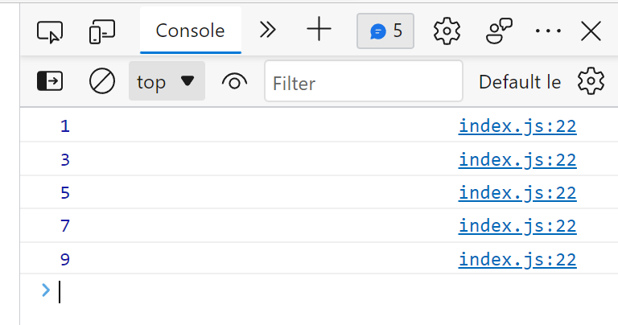

E.g., when i is 2, it is an even number, and then we increment i… so i will be 3. When the javascript engine sees the keyword continue… it will jump to the beginning of the loop…

while (i <= 10) {

…and continue execution of the next iteration.

At this point, i is 3, and the if statement is not executed. That is why we see i logged on the console as 3. [[[In other words, if the *if* statement conditions are met, then it continues to the beginning, and does not reach the console.log]]]

Mosh does not use continue that often… it is old, legacy code. But you may see it in projects that you are working on. “It is an ugly way of writing code.”

With the break keyword we jump out of a loop, and with the continue keyword, jump to the next iteration [[[at the top]]].

## 04 - Control Flow - Exercise - 10 - Max of Two Numbers

“I want you to write a function that takes two numbers and returns the maximum of the two.

Call that function, give a different argument, and make sure it is working properly”.

OK, first attempt, while yielding the correct answer, is Not a function. Mosh does indeed want a function.

if (10>20) {console.log(10)}

else

console.log(20)

I see this much from his lesson, so maybe I can finish:

*function maximum (number1, )*

This is a fail:

function maximum (number1, number2) {

    if (number1 > number2) {console.log(number1)

    else

console.log(number2)}

}

let number1 = 10

let number2 = 20

Well, let’s play with our if…else just for fun:

if (number1 > number2) {console.log(number1)}

else

console.log(number2)

let number1 = 10

let number2 = 20

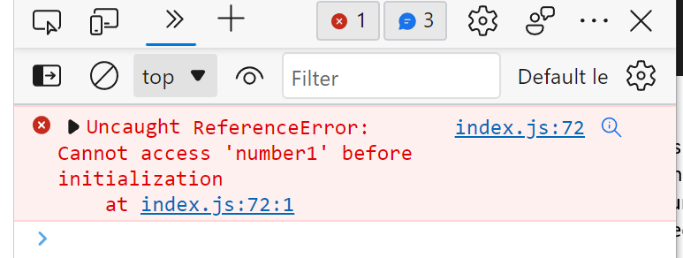

Ah… need to input the values Before executing the code.

let number1 = 10

let number2 = 20

if (number1 > number2) {console.log(number1)}

else

console.log(number2)

Ah, that works.

This does not:

let number1 = 10

let number2 = 20

function maximum(number1, number2) {

    if (number1 > number2) {console.log(number1)}

    else

console.log(number2)}

}

This does not work:

function maximum(1, 5) {

    if (1 > 5) {console.log(1)}

    else

console.log(5) }

Well, this doesn’t throw an error message:

function maximum(number1, number2) {

    return number1 > number2;

}

Nor does this… I thought I saw that it did… hmm.

function maximum(number1, number2) {

    return number1 > number2;

    return number1 < number2;

}

This just returns False:

function maximum(number1, number2) {

    return number1 > number2;

    return number1 < number2;

}

console.log(maximum(10, 20));

This returns true:

function maximum(number1, number2) {

    return number1 > number2;

    return number1 < number2;

}

console.log(maximum(10, 5));

Well… I can’t just log the output of maximum, because I have two outputs.

Ok, well this worked:

function maximum(number1, number2) {

    if (number1 > number2) return number1

    else return number2

}

console.log(maximum(10, 20));

So did this:

function maximum(number1, number2) {

    if (number1 > number2) {return number1}

    else return number2

}

console.log(maximum(50, 20));

Perhaps this is better?

function maximum(number1, number2) {

    if (number1 > number2) {return number1;}

    else return number2;

}

console.log(maximum(50, 20));

Well… it may all be nonsense.  
  
  
Hmmm, better still?

function maximum(number1, number2) {

    if (number1 > number2) {return number1;

    }

    else return number2;

}

console.log(maximum(50, 20));

Now, let’s follow along with Mosh:

Let’s start by defining a function, will call it Max. We will add two parameters: number one, and number two.

function max(number1, number2)

Or we can use shorter names like a and B. Mosh says A and B are kind of self-explanatory in this case, so we can go ahead and use these undefined names which he normally warned against.

“We want to have some logic, we want to compare the value of a with B, so were going to use an if statement”

If a is greater than be, we want to return a.

if (a > b) return a;

Else, we want to return b.

function max(a, b) {

if (a > b) return a;

else return b;

}

“This is the simplest implementation, it’s not the best”.

Let’s declare a variable called number, and set it to max of one and two.

let number = max(1, 2);

let number = max(1, 2);

function max(a, b) {

if (a > b) return a;

else return b;

}

Now we’ll display the number on the console.

let number = max(1, 2);

console.log(number);

function max(a, b) {

if (a > b) return a;

else return b;

}

(Mosh notes that we “called this function, with different arguments. Different test cases” I.e., different numbers.

Let’s clean up this code. Let’s remove the *else* keyword. Mosh says that if a is true, we will return A and jump out of the function, and the subsequent code won’t be executed. If A is untrue, we should just return b.

return b;

let number = max(1, 2);

console.log(number);

function max(a, b) {

if (a > b) return a;

return b;

}

We can use the conditional operator to make this even simpler. We have a (condition) in parenthesis, a ?, and if this condition evaluates to true, we use one value, otherwise we use the other.

(condition) ? a : b.

Jumping out of the lesson. Hmmm. How can I implement this?

This comes back as undefined:

let number = max(1, 2);

console.log(number);

function max(a, b) {

(a > b) ? a : b

}

Ah, this did it:

return (a > b) ? a : b

let number = max(1, 2);

console.log(number);

function max(a, b) {

return (a > b) ? a : b

}

Back to Mosh:

We use the conditional operator. For the condition, is A > B. If this condition is true ? return A. Otherwise return B.

a > b) ? a : b

let number = max(1, 2);

console.log(number);

function max(a, b) {

(a > b) ? a : b

}

All we need is a return statement, and to terminate with a semicolon.

return (a > b) ? a : b;

let number = max(1, 2);

console.log(number);

function max(a, b) {

return (a > b) ? a : b;

}

## 04 - Control Flow - Exercise - 11 - Landscape or Portrait

function isLandscape(width, height) {

}

Implement this function. Function, isLandscape, and it takes two parameters. Width, and height of an image.

Returns true if the image is landscape, meaning width is greater than height. Otherwise, it returns false. This is similar to the previous exercise, but Mosh has a tip.

So, we want to return a Boolean instead of a numerical value, I guess. I think I did that accidentally earlier…

OK, this did not work… wait, it did. I just had to reload the browser

let boolean = isLandscape(5, 2);

console.log(boolean)

function isLandscape(width, height) {

    if (width > height) return true

   return false

}

We could pare this down:

let boolean = isLandscape(5, 2);

console.log(boolean)

function isLandscape(w, h) {

    if (w > h) return true

    return false

}

Let’s see if we can do the same thing with our conditional operator.

Well, this didn’t work.

let boolean = isLandscape(5, 2);

console.log(boolean)

function isLanscape(w, h) {

    (w > h) ? true : false

}

Nor did this, when we added return:

let boolean = isLandscape(5, 2);

console.log(boolean)

function isLanscape(w, h) {

return (w > h) ? true : false

}

Ah ha… this Does work. The one above had a Typo in isLandscape. Duuuur.

let boolean = isLandscape(1, 2);

console.log(boolean);

function isLandscape(w, h) {

    return (w > h) ? true : false;

}

Interestingly enough, this did not work… when I capitalized False:

let boolean = isLandscape(1, 2);

console.log(boolean);

function isLandscape(w, h) {

    return (w > h) ? true : False;

}

Though it did work when I turned it into a string:

let boolean = isLandscape(1, 2);

console.log(boolean);

function isLandscape(w, h) {

    return (w > h) ? 'true' : 'False';

}

Now, we do it Mosh’s way.

function isLandscape(width, height) {

    if (width > height) return true;

    return false;

}

Using the conditional operator:

function isLandscape(width, height) {

    return (width > height) ? true : false;

}

However, the code above “looks very amateurish. You don’t want to return true or false explicitly. This is very ugly”.

The reason being that we can delete the conditional operator, “and simply return the value of this expression”.

function isLandscape(width, height) {

    return (width > height) ? true : false;

}

If width is greater than height, the expression will be evaluated to true. If width is less than height, this expression will evaluate to false. “So there is no need to explicitly return true and false here. That’s a poor way of writing code”.

Let’s do a console.log. “Simply call this function here, isLandscape”

console.log(isLandscape)

function isLandscape(width, height) {

    return (width > height)

}

Let’s pass the dimensions 800 x 600:

console.log(isLandscape(800, 600));

function isLandscape(width, height) {

    return (width > height)

}

let boolean = isLandscape(5, 2);

console.log(boolean)

function isLandscape(w, h) {

    if (w > h) return true

     return false

}

let boolean = isLandscape(1, 2);

console.log(boolean);

function isLandscape(w, h) {

    return (w > h) ? true : false;

}

function isLandscape(width, height) {

    if (width > height) return true;

    return false;

}

function isLandscape(width, height) {

    return (width > height) ? true : false;

}

function isLandscape(width, height) {

    return (width > height)

}

*/

console.log(isLandscape(300, 600));

function isLandscape(width, height) {

    return (width > height)

}

## 04 - Control Flow - Exercise - 12 - FizzBuzz

This question is a popular interview question called the fizz buzz algorithm.

So, we have this function called fizzBuzz. We give it an input, and it returns a string.

function fizzBuzz(input) {

}

Let’s declare a constant called output… here we *call* fizzBuzz, and pass an input, like 3

const output = fizzBuzz(3);

function fizzBuzz(input) {

}

Now, log the output:

const output = fizzBuzz(3);

console.log(output);

function fizzBuzz(input) {

}

Mosh’s console outputs Fizz. Mine does not. It just says undefined. I tried switching from edge to chrome, no difference.

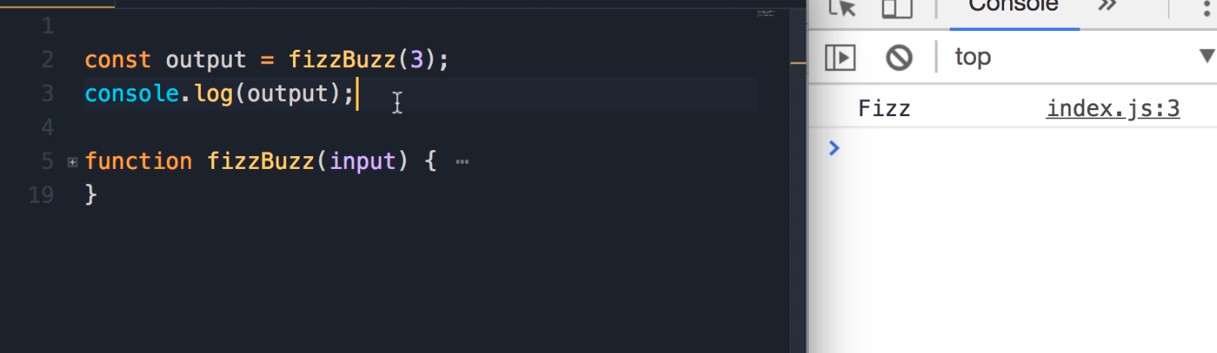

“So if the number that we pass is divisible by three, we get Fizz.”

If the number that we pass is divisible by 5, we get Buzz.

If the number we pass is divisible by 3 and 5, like 15, we get fizzBuzz

If the number is not divisible by either 3 or 5, we get the same number… e.g., 7.

if (hour >= 6 && hour < 12 )

    console.log('Good morning');

else if (hour >= 12 && hour < 18)

    console.log('Good Afternoon!');

else

console.log('Good evening');

Let’s aim for outputting just one variable. Switch and case seems another way.

Hmmm. Looks like Mosh used if. We’ll try switch and case too.

const output = fizzBuzz(3);

console.log(output);

function fizzBuzz(input) {if 10 > 1 return true; }

So my problem is, I’m not sure how to output anything.

Ah. Had to put this in parenthesis.

const output = fizzBuzz(3);

console.log(output);

function fizzBuzz(input) {if (10 > 1)

    return true; }

This outputs an error.

const output = fizzBuzz(6);

console.log(output);

function fizzBuzz(input) {if (i % 3 !== 0)

    return true; }

This outputs true

const output = fizzBuzz(6);

console.log(output);

function fizzBuzz(input) {if (fizzBuzz % 3 !== 0)

    return true; }

returns fizz

const output = fizzBuzz(6);

console.log(output);

function fizzBuzz(input) {if (fizzBuzz % 3 !== 0)

    return 'fizz'; }

ah… returns true, even if the number Isn’t divisible by 3.

const output = fizzBuzz(2);

console.log(output);

function fizzBuzz(input) {if (fizzBuzz % 3 !== 0)

    return 'fizz'; }

Ahhh. The !== means Not divisible? === outputs false

const output = fizzBuzz(2);

console.log(output);

function fizzBuzz(input) {if (fizzBuzz % 3 %== 0)

    return 'fizz';

else return false }

Changing fizzbuzz to 5 yields the same result:

const output = fizzBuzz(5);

console.log(output);

function fizzBuzz(input) {if (5 % 2 !== 0)

    return 'fizz';

else return false }

Ah… this needed to be changed to input… durr.

const output = fizzBuzz(4);

console.log(output);

function fizzBuzz(input) {if (input % 2 !== 0)

    return 'fizz';

else return false }

Ok, so this works for 3:

const output = fizzBuzz(3);

console.log(output);

function fizzBuzz(input) {if (input % 3 === 0)

    return 'fizz';

else return false }

Logical And && washed out…

const output = fizzBuzz(15);

console.log(output);

function fizzBuzz(input) {if (input % 3 === 0 && input % 5 === 0)

    return fizzBuzz

    (input % 3 === 0)

    return 'fizz';

else return false }

So did this:

function fizzBuzz(input) {if ((input % 3 === 0) && (input % 5 === 0))

    return fizzBuzz

    (input % 3 === 0)

    return 'fizz';

else return false }

Removing the 3 code produces a weird error:

const output = fizzBuzz(15);

console.log(output);

function fizzBuzz(input) {if ((input % 3 === 0) && (input % 5 === 0))

    return fizzBuzz

else return false }

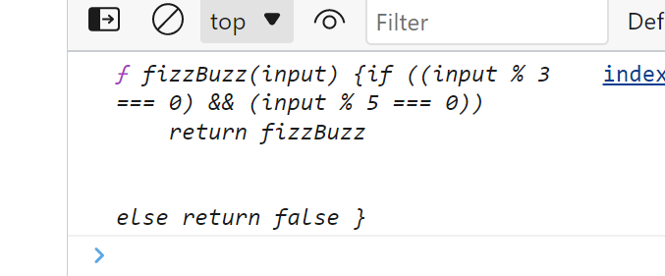

This gives us a regular error:

const output = fizzBuzz(15);

console.log(output);

function fizzBuzz(input) {if ((input % 3 === 0) && (input % 5 === 0));

    return fizzBuzz

else return false }

Hey dummy… did you remember to pass a string? This works:

const output = fizzBuzz(30);

console.log(output);

function fizzBuzz(input) {if (input % 3 === 0 && input % 5 === 0)

    {return 'fizzBuzz';}

else return false }

We can pare this back down… I had tried a few things:

const output = fizzBuzz(30);

console.log(output);

function fizzBuzz(input) {if (input % 3 === 0 && input % 5 === 0)

    return 'fizzBuzz'

else return false }

Ok… now to try not divisible by either:

const output = fizzBuzz(9);

console.log(output);

function fizzBuzz(input) {if (input % 3 === 0 && input % 5 === 0)

    return 'fizzBuzz'

    else if (input % 3 === 0)

    return 'fizz'

    else if (input % 3 !== 0 && input % 5 !==)

    return (input)

else return false }

This kinda works

const output = fizzBuzz(11);

console.log(output);

function fizzBuzz(input) {if (input % 3 === 0 && input % 5 === 0)

    return 'fizzBuzz'

    else if (input % 3 === 0)

    return 'fizz'

    else if (input % 3 !== 0)

    return (input)

else return false }

Hmmm. 10 returns false… maybe I need to write up something for 5 now:

const output = fizzBuzz(10);

console.log(output);

function fizzBuzz(input) {if (input % 3 === 0 && input % 5 === 0)

    return 'fizzBuzz'

    else if (input % 3 === 0)

    return 'fizz'

    else if (input % 3 !== 0  && input % 5 !== 0)

    return (input)

else return false }

Ok, this works great:

const output = fizzBuzz(101);

console.log(output);

function fizzBuzz(input) {if (input % 3 === 0 && input % 5 === 0)

    return 'fizzBuzz'

    else if (input % 3 === 0)

    return 'fizz'

    else if (input % 5 === 0)

    return 'Buzz'

    else if (input % 3 !== 0  && input % 5 !== 0)

    return (input)

else return 'false' }

This doesn’t work. Error message.

const output = fizzBuzz(dog);

console.log(output);

function fizzBuzz(input) {if (input % 3 === 0 && input % 5 === 0)

    return 'fizzBuzz'

    else if (input % 3 === 0)

    return 'fizz'

    else if (input % 5 === 0)

    return 'Buzz'

    else if (input % 3 !== 0  && input % 5 !== 0)

    return (input)

else return 'Not a number' }

If we input the string, we get back the string… instead of not a number.

const output = fizzBuzz('dog');

console.log(output);

function fizzBuzz(input) {if (input % 3 === 0 && input % 5 === 0)

    return 'fizzBuzz'

    else if (input % 3 === 0)

    return 'fizz'

    else if (input % 5 === 0)

    return 'Buzz'

    else if (input % 3 !== 0  && input % 5 !== 0)

    return (input)

else return 'Not a number' }

Hmmm. How do we get the return input to exclude non numbers? I tried making input divisible by 1… also tried input plus 1

const output = fizzBuzz('dog');

console.log(output);

function fizzBuzz(input) {if (input % 3 === 0 && input % 5 === 0)

    return 'fizzBuzz'

    else if (input % 3 === 0)

    return 'fizz'

    else if (input % 5 === 0)

    return 'Buzz'

    else if

    else if (input % 3 !== 0  && input % 5 !== 0)

    return (input % 1 === 0)

else return 'Not a number' }

Haha. Input plus zero is thus: (outputted dog0)

const output = fizzBuzz('dog');

console.log(output);

function fizzBuzz(input) {if (input % 3 === 0 && input % 5 === 0)

    return 'fizzBuzz'

    else if (input % 3 === 0)

    return 'fizz'

    else if (input % 5 === 0)

    return 'Buzz'

    else if (input % 3 !== 0  && input % 5 !== 0)

    return (input + 0)

else return 'Not a number' }

Ok, dog input % 1 is false.

const output = fizzBuzz('dog');

console.log(output);

function fizzBuzz(input) {if (input % 3 === 0 && input % 5 === 0)

    return 'fizzBuzz'

    else if (input % 3 === 0)

    return 'fizz'

    else if (input % 5 === 0)

    return 'Buzz'

    else if (input % 3 !== 0  && input % 5 !== 0)

    return (input % 1 === 0)

else return 'Not a number' }

Non 3, 5 and either numbers output to true. Strings output to ‘Not a number’. False, outputs to fizzbuzz. True, outputs to true.

const output = fizzBuzz(17);

console.log(output);

function fizzBuzz(input) {if (input % 3 === 0 && input % 5 === 0)

    return 'fizzBuzz'

    else if (input % 3 === 0)

    return 'fizz'

    else if (input % 5 === 0)

    return 'Buzz'

    else if (input % 1 !== 0)

    return 'Not a number'

    else if (input % 3 !== 0  && input % 5 !== 0)

    return (input % 1 === 0)

}

Ok, so instead of input % 1, we did input/1. Plus some rearranging. Everything seems to work.

const output = fizzBuzz(14);

console.log(output);

function fizzBuzz(input) {if (input === true)

    return 'Not a number'

    else if (input === false)

    return 'Not a number'

    else if (input % 1 !== 0)

    return 'Not a number'

    else if (input % 3 === 0 && input % 5 === 0)

    return 'fizzBuzz'

    else if (input % 3 === 0)

    return 'fizz'

    else if (input % 5 === 0)

    return 'Buzz'

    else if (input % 3 !== 0  && input % 5 !== 0)

    return (input/1)

}

Wait… why would we need input/1? Just input. Must have been bad formatting before:

const output = fizzBuzz(false);

console.log(output);

function fizzBuzz(input) {if (input === true)

    return 'Not a number'

    else if (input === false)

    return 'Not a number'

    else if (input % 1 !== 0)

    return 'Not a number'

    else if (input % 3 === 0 && input % 5 === 0)

    return 'fizzBuzz'

    else if (input % 3 === 0)

    return 'fizz'

    else if (input % 5 === 0)

    return 'Buzz'

    else if (input % 3 !== 0 && input % 5 !== 0)

    return (input)

Let’s see Mosh’s solution. Ahh. Here is what we wanted.

const output = fizzBuzz(false);

console.log(output);

function fizzBuzz(input) {

    if (typeof input !== 'number')

   return 'Not a number'

}

“Here we’re dealing with a complex expression. To make this code more readable, I would like to put each expression in parenthesis.”

const output = fizzBuzz(false);

console.log(output);

function fizzBuzz(input) {

    if (typeof input !== 'number')

   return 'Not a number';

   if (input % 3 === 0)

   return 'Fizz';

   if (input % 5 === 0)

   return 'Buzz';

   if (input % 3 === 0 && input % 5 === 0)

}

Select the parenthesis, type ( and it will automatically enclose it ^^ tips and tricks.

const output = fizzBuzz(false);

console.log(output);

function fizzBuzz(input) {

    if (typeof input !== 'number')

   return 'Not a number';

   if (input % 3 === 0)

   return 'Fizz';

   if (input % 5 === 0)

   return 'Buzz';

   if ((input % 3 === 0) && (input % 5 === 0))

}

Ah, ha. Mosh pulled a fast one on us. He is showing that order of operation matters. Also, to move code, select it, push the alt key, and the arrows ^^. Tips and tricks.

console.log(output);

function fizzBuzz(input) {

    if (typeof input !== 'number')

   return 'Not a number';

   if ((input % 3 === 0) && (input % 5 === 0))

   return 'FizzBuzz';

   if (input % 3 === 0)

   return 'Fizz';

   if (input % 5 === 0)

   return 'Buzz';

   return input;

}

In JS, there is a special value called Not A Number. NaN

const output = fizzBuzz(dog);

console.log(output);

function fizzBuzz(input) {

    if (typeof input !== 'number')

   return NaN;

   if ((input % 3 === 0) && (input % 5 === 0))

   return 'FizzBuzz';

   if (input % 3 === 0)

   return 'Fizz';

   if (input % 5 === 0)

   return 'Buzz';

   return input;

}

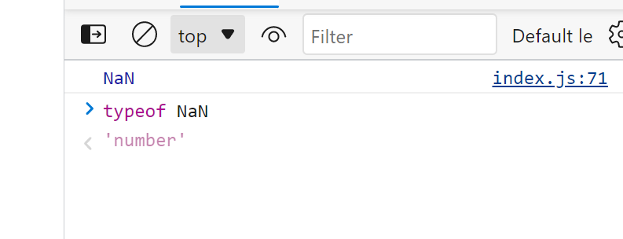

NaN returns as a number. Weird. But it isn’t a valid mathematical number.

/*

divisible by 3, => Fizz

divisibile by 5 => Buzz

divisible by both 3 and 5 => FizzBuzz

Not divisible by 3 or 5 => input

not a number => 'Not a number"

 (input % 3 === 0)

    return 'fizz';

    const output = fizzBuzz(false);

console.log(output);

function fizzBuzz(input) {

const output = fizzBuzz(7);

console.log(output);

function fizzBuzz(input) {if (input === true)

    return 'Not a number'

    else if (input === false)

    return 'Not a number'

    else if (input % 1 !== 0)

    return 'Not a number'

    else if (input % 3 === 0 && input % 5 === 0)

    return 'fizzBuzz'

    else if (input % 3 === 0)

    return 'fizz'

    else if (input % 5 === 0)

    return 'Buzz'

    else if (input % 3 !== 0 && input % 5 !== 0)

    return (input)

}

*/

const output = fizzBuzz(false);

console.log(output);

function fizzBuzz(input) {

    if (typeof input !== 'number')

   return NaN;

   if ((input % 3 === 0) && (input % 5 === 0))

   return 'FizzBuzz';

   if (input % 3 === 0)

   return 'Fizz';

   if (input % 5 === 0)

   return 'Buzz';

   return input;

}

## 04 - Control Flow - Exercise - 13 - Demerit Points

Mosh says this is more difficult than the earlier exercises.

checkSpeed(50);

function checkspeed(speed) {

}

This function takes a parameter that’s the speed of a car. Speed Limit is 70 kph.

So, if a car is driving under or at the speed limit, output OK.

For every 5 above the speed limit, they get 1 point.

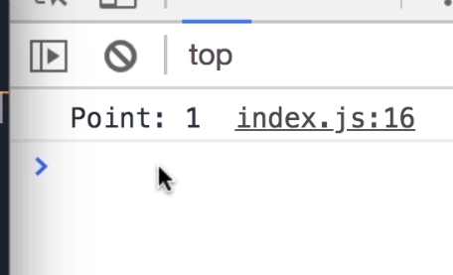

If you are at 72… still output to OK.

“As part of calculating the point here, you’ll have to use one of the built in functions in JS. Math.floor.

Math.floor

checkSpeed(50);

function checkspeed(speed) {

}

We can give this function a floating point number like 1.3… or 1.3 points… and this will convert that to the greatest integer.

Math.floor(1.3)

checkSpeed(50);

function checkspeed(speed) {

}

If we pass 80, we get 2 points. If we do 180, it outputs License suspended. So… if a driver gets more than 12 points, license suspended.

Same trouble as usual. How do I get this out output anything?

Math.floor(1.3)

checkSpeed(50);

function checkspeed(speed) {console.log(checkspeed)

}

Math.floor(1.3)

checkSpeed(50);

function checkspeed(speed) {console.log(speed)

}

Math.floor(1.3)

checkSpeed(50);

function checkspeed(speed) {return console.log(speed)

}

Ah ha… we first discover a Typo! Now we are outputting. Displays 50.

checkSpeed(50);

function checkSpeed(speed) {console.log(speed);

}

Trying to log checkSpeed, does this recursive thing, displaying the entire function:

checkSpeed(50);

function checkSpeed(speed) {console.log(checkSpeed);

}

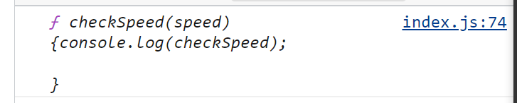

Ok, now we’ll add a condition. And over 75, we don’t display.

checkSpeed(50);

function checkSpeed(speed) { if (speed < 75) console.log(speed);

}

Now, we try to output the string OK, and we fail… oh, duh, because we are over 75.

checkSpeed(90);

function checkSpeed(speed) { if (speed < 75) console.log('OK');

}

Durrr.

checkSpeed(40);

function checkSpeed(speed) { if (speed < 75) console.log('OK');

}

Ok, if speed is less than or equal to 74… we return OK.

checkSpeed(40);

function checkSpeed(speed) { if (speed <= 75) console.log('OK');

}

So, 12 times 5 is 60. Max speed is 130

So, subtracting 75 from speed, and then dividing by 5 seems like the answer… just need to output it.

checkSpeed(80);

function checkSpeed(speed) { if (speed <= 74) console.log('OK');

else if console.log((speed) - 75)

}

Ah… here we are.

checkSpeed(80);

function checkSpeed(speed) { if (speed <= 74) console.log('OK');

else if (speed >= 75)

console.log(speed -75)

}

OK… better still:

checkSpeed(80);

function checkSpeed(speed) { if (speed <= 74) console.log('OK');

else if (speed >= 75)

console.log((speed -75)/5)

}

Now, here’s the string:

checkSpeed(80);

function checkSpeed(speed) { if (speed <= 74) console.log('OK');

else if (speed >= 75)

console.log('Point: '+ (speed -75)/5)

}

Ah… but 75 is Zero points.

checkSpeed(75);

function checkSpeed(speed) { if (speed <= 74) console.log('OK');

else if (speed >= 75)

console.log('Point: '+ (speed -75)/5)

}

OK… 75 is 1 point now:

checkSpeed(75);

function checkSpeed(speed) { if (speed <= 74) console.log('OK');

else if (speed >= 75)

console.log('Point: '+ ((speed -75)/5 + 1) )

}

Ah ha… 89 comes out to 3.8:

checkSpeed(89);

function checkSpeed(speed) { if (speed <= 74) console.log('OK');

else if (speed >= 75)

console.log('Point: '+ ((speed -75)/5 + 1) )

}

Ah ha… here is Math.floor, changing a 91 to a whole number:

checkSpeed(91);

function checkSpeed(speed) { if (speed <= 74) console.log('OK');

else if (speed >= 75)

console.log('Point: '+ (Math.floor((speed -75)/5 + 1)) )

}

OK… now all we have to do is make sure this only applies to under 130.

checkSpeed(140);

function checkSpeed(speed) { if (speed <= 74) console.log('OK');

else if (speed >= 75  && speed < 130)

console.log('Point: '+ (Math.floor((speed -75)/5 + 1)) )

 return console.log('License Suspended')

}

However, if Under 130, we still get points displaying:

checkSpeed(100);

function checkSpeed(speed) { if (speed <= 74) console.log('OK');

else if (speed >= 75  && speed < 130)

console.log('Point: '+ (Math.floor((speed -75)/5 + 1)) )

 return console.log('License Suspended')

}

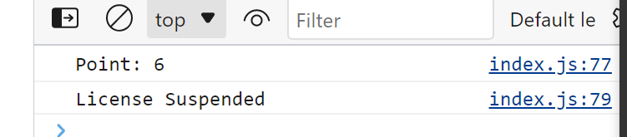

Ah… just have to add else

checkSpeed(90);

function checkSpeed(speed) { if (speed <= 74) console.log('OK');

else if (speed >= 75  && speed < 130)

console.log('Point: '+ (Math.floor((speed -75)/5 + 1)) )

else return console.log('License Suspended')

}

OK… problem solved.

Lets see Mosh’s Solution.

“The first thing I want to improve here is to turn this magic number into a constant. Because someone else looking at this code may not know what 70 represents here. So you should avoid using magic numbers in your code. Always use constants to describe them”

function checkSpeed(speed) {

    if (speed < 70)

    console.log('OK');

}

We establish a constant speedLimit, and then change (speed < 70) to (speed < speedLimit).

function checkSpeed(speed) {

**const speedLimit = 70;**

    if (speed < speedLimit)

    console.log('OK');

}

“With this change, now our code is more expressive, and also if we want to use this number somewhere else in this function, we don’t have to repeat it multiple times. We have defined it **here** once, and we can reuse it in multiple places.

If tomorrow, the speed limit changes to, let’s say, 75 or 65, there is only a single place we have to change.”

“Once again, we don’t want to use this magic number here… it’s not descriptive.”

function checkSpeed(speed) {

    const speedLimit = 70;

    if (speed < speedLimit)

    console.log('OK');

    else {

         (speed - speedLimit) / 5

    }

}

Instead, we define another constant. Kilometer per point:

function checkSpeed(speed) {

    const speedLimit = 70;

    const kmPerPoint = 5;

    if (speed < speedLimit)

    console.log('OK');

    else {

         (speed - speedLimit) / kmPerPoint

    }

}

“With this we get the number of points”. And Mosh changes this to: *let points = (speed - speedLimit) / kmPerPoint;*

function checkSpeed(speed) {

    const speedLimit = 70;

    const kmPerPoint = 5;

    if (speed < speedLimit)

    console.log('OK');

    else {

         let points = (speed - speedLimit) / kmPerPoint;

    }

}

The result of this expression can be a floating point number.

function checkSpeed(speed) {

    const speedLimit = 70;

    const kmPerPoint = 5;

    if (speed < speedLimit)

    console.log('OK');

    else {

         let points = (speed - speedLimit) / kmPerPoint;

    }

}

So, let’s call Math.floor… and as an argument, we pass the highlighted expression:

function checkSpeed(speed) {

    const speedLimit = 70;

    const kmPerPoint = 5;

    if (speed < speedLimit)

    console.log('OK');

    else {

         let points = Math.floor((speed - speedLimit) / kmPerPoint);

    }

}

“Now we should check to see if the driver gets more than 12 points. So, we need another if statement. If points is greater than or equal to 12, we want to suspend their license.”

[[[I’d note that this is basically a *let* *if* statement. Interesting. ]]]

function checkSpeed(speed) {

    const speedLimit = 70;

    const kmPerPoint = 5;

    if (speed < speedLimit)

    console.log('OK');

    else {

         let points = Math.floor((speed - speedLimit) / kmPerPoint);

         if (points >= 12)

         console.log('License suspended')

    }

}

“Otherwise, we want to display the number of points on the console… and as a second argument, we pass this points variable” [[[The first is string, the second is a value]]]

   else

         console.log('Points', points);

function checkSpeed(speed) {

    const speedLimit = 70;

    const kmPerPoint = 5;

    if (speed < speedLimit)

    console.log('OK');

    else {

         let points = Math.floor((speed - speedLimit) / kmPerPoint);

         if (points >= 12)

         console.log('License suspended')

         else

         console.log('Points', points);

    }

}

“Now technically here I could also use a constant, and that’s a better practice to make sure I don’t accidentally modify this points here”

function checkSpeed(speed) {

    const speedLimit = 70;

    const kmPerPoint = 5;

    if (speed < speedLimit)

    console.log('OK');

    else {

         let points = Math.floor((speed - speedLimit) / kmPerPoint);

         if (points >= 12)

         console.log('License suspended')

         else

         console.log('Points', points);

    }

}

So, we’ll change this to a constant:

function checkSpeed(speed) {

    const speedLimit = 70;

    const kmPerPoint = 5;

    if (speed < speedLimit)

    console.log('OK');

    else {

         const points = Math.floor((speed - speedLimit) / kmPerPoint);

         if (points >= 12)

         console.log('License suspended')

         else

         console.log('Points', points);

    }

}

And if we try to modify the points like so, we’ll get an error:

function checkSpeed(speed) {

    const speedLimit = 70;

    const kmPerPoint = 5;

    if (speed < speedLimit)

    console.log('OK');

    else {

         const points = Math.floor((speed - speedLimit) / kmPerPoint);

         points++;

         if (points >= 12)

         console.log('License suspended')

         else

         console.log('Points', points);

    }

}

“Const should be your default choice. If you want to reassign a variable, that’s when you use the let keyword.”

“Let’s call this function, *checkSpeed* and pass 50.

checkSpeed(50);

checkSpeed(50);

function checkSpeed(speed) {

    const speedLimit = 70;

    const kmPerPoint = 5;

    if (speed < speedLimit)

    console.log('OK');

    else {

         const points = Math.floor((speed - speedLimit) / kmPerPoint);

         if (points >= 12)

         console.log('License suspended')

         else

         console.log('Points', points);

    }

}

If we drive exactly at the speed limit, we get “Points 0”, instead of the OK message. So there is a bug in our condition here. Let’s change it to less than or equal to. [[[I’m not repasting that small change.]]]

checkSpeed(70);

function checkSpeed(speed) {

    const speedLimit = 70;

    const kmPerPoint = 5;

    if (speed < speedLimit)

    console.log('OK');

    else {

         const points = Math.floor((speed - speedLimit) / kmPerPoint);

         if (points >= 12)

         console.log('License suspended')

         else

         console.log('Points', points);

    }

}

Ok… now if you’re going 71, you get the “Points 0” message instead of OK. So, we still have a bug.

Let’s change

 if (speed <= speedLimit)

to:

    if (speed < speedLimit + kmPerPoint)

[[[kmPerPoint is 5… so it’s basically like adding 5. Then we change it to less than]]]

checkSpeed(70);

function checkSpeed(speed) {

    const speedLimit = 70;

    const kmPerPoint = 5;

    if (speed < speedLimit)

    console.log('OK');

    else {

         const points = Math.floor((speed - speedLimit) / kmPerPoint);

         if (points >= 12)

         console.log('License suspended')

         else

         console.log('Points', points);

    }

}

“So our function is working. I just want to show you one more tip to make our code cleaner.

Here, we have this else block, and this has caused indentation here[[[ here being, say, the space before const]]]. “Now this is not a terribly bad thing, but it is better to avoid indentation if we can. Because otherwise we have to scroll to the left and right to see what’s happening here.”

checkSpeed(70);

function checkSpeed(speed) {

    const speedLimit = 70;

    const kmPerPoint = 5;

    if (speed <= speedLimit + kmPerPoint)

    console.log('OK');

    else {

         const points = Math.floor((speed - speedLimit) / kmPerPoint);

         if (points >= 12)

         console.log('License suspended')

         else

         console.log('Points', points);

    }

}

“So, if this condition is true, we want to display ok on the console. To get rid of this else block…”

checkSpeed(70);

function checkSpeed(speed) {

    const speedLimit = 70;

    const kmPerPoint = 5;

    if (speed <= speedLimit + kmPerPoint)

    console.log('OK');

    else {

         const points = Math.floor((speed - speedLimit) / kmPerPoint);

         if (points >= 12)

         console.log('License suspended')

         else

         console.log('Points', points);

    }

}

“…We can add a block here” and stick console.log inside it. And then add a return after: “With this we will jump out of this function, and none of the code **here** will be executed”

 if (speed <= speedLimit + kmPerPoint) {

        console.log('OK');

        return;

    }

checkSpeed(70);

function checkSpeed(speed) {

    const speedLimit = 70;

    const kmPerPoint = 5;

    if (speed <= speedLimit + kmPerPoint) {

        console.log('OK');

        return;

    }

**else {**

**const points = Math.floor((speed - speedLimit) / kmPerPoint);**

**if (points >= 12)**

**console.log('License suspended')**

**else**

**console.log('Points', points);**

    }

}

Now we can remove the else statement and the code block, and remove the indentation:

checkSpeed(70);

function checkSpeed(speed) {

    const speedLimit = 70;

    const kmPerPoint = 5;

    if (speed <= speedLimit + kmPerPoint) {

        console.log('OK');

        return;

    }

    const points = Math.floor((speed - speedLimit) / kmPerPoint);

    if (points >= 12)

    console.log('License suspended')

    else

    console.log('Points', points);

}

/*

My solution:

checkSpeed(80);

function checkSpeed(speed) { if (speed <= 74) console.log('OK');

else if (speed >= 75  && speed < 130)

console.log('Point: '+ (Math.floor((speed -75)/5 + 1)) )

else return console.log('License Suspended')

}

*/

checkSpeed(70);

function checkSpeed(speed) {

    const speedLimit = 70;

    const kmPerPoint = 5;

    if (speed <= speedLimit + kmPerPoint) {

        console.log('OK');

        return;

    }

    const points = Math.floor((speed - speedLimit) / kmPerPoint);

    if (points >= 12)

    console.log('License suspended')

    else

    console.log('Points', points);

}

## 04 - Control Flow - 14 - Exercise 5 - Even and Odd Numbers

Write a function called show numbers that takes a parameter called limit. So, we pass a number here like 10, and when we call this function, we should see all the numbers from zero to the number we supplied as the limit.

showNumbers(10);

function showNumbers(limit) {

}

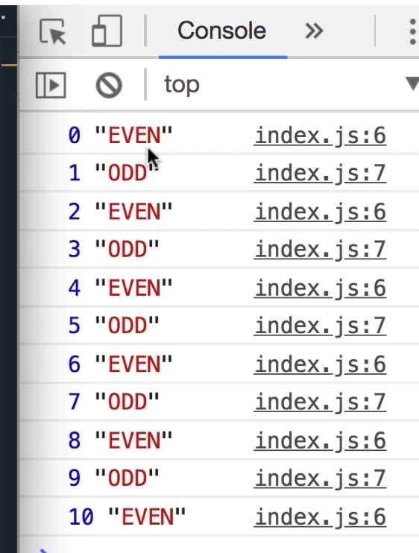

“Next to each number, if that number is even, you should display the even label. Otherwise, you should display odd”

Mosh says this is easy. Looks like a loop of some kind. Let’s see if we can make something display:

Fail.

showNumbers(10);

function showNumbers(limit) {

    for (let i = 0; i < limit)

    console.log(i)

}

OK… this displays.

showNumbers(10);

function showNumbers(limit) {

    let i = 0;

    console.log(i)

}

But this does Not work:

showNumbers(10);

function showNumbers(limit) {

    (let i = 0;)

    console.log(i)

}

This does:

showNumbers(10);

function showNumbers(limit) {

    let i = 0;

    i <= limit;

    console.log(i)

}

This only iterates once:

showNumbers(10);

function showNumbers(limit) {

    let i = 0;

    i <= limit;

    i++

    console.log(i)

}

Huh. This works… why didn’t the earlier expressions? Maybe they did

showNumbers(10);

function showNumbers(limit) {

    for (let i = 0;

    i <= limit;

    i++)

    console.log(i)

}

Well, no replacing for with let, willy nilly. This didn’t work:

showNumbers(10);

function showNumbers(limit) {

    if (let i = 0;

    i <= limit;

    i++)

    console.log(i)

}

This only displays even numbers, 0 to 10:

showNumbers(10);

function showNumbers(limit) {

    for (let i = 0;

    i <= limit;

    i++)

    {if (i % 2 === 0) console.log(i + ' ' + "EVEN")}

Well… this is no good. Just an error message:

showNumbers(10);

function showNumbers(limit) {

    for (let i = 0;

    i <= limit;

    i++)

    {if (i % 2 === 0) console.log(i + ' ' + "EVEN") || (i % 2 !== 0) console.log}

Hmm. This was an error:

showNumbers(10);

function showNumbers(limit) {

    for (let i = 0;

    i <= limit;

    i++)

    {if (i % 2 === 0) console.log(i + ' ' + "EVEN")}

    {if (i % 2 !== 0) console.log(i + ' ' + "ODD")}

}

Ok… so this works with an *if else*.

showNumbers(10);

function showNumbers(limit) {

    for (let i = 0;

    i <= limit;

    i++)

    {if (i % 2 === 0) console.log(i + ' ' + '"EVEN"')

    else if (i % 2 !== 0) console.log(i + ' ' + '"ODD"')

}

}

I note that inputting true gives me weird results.

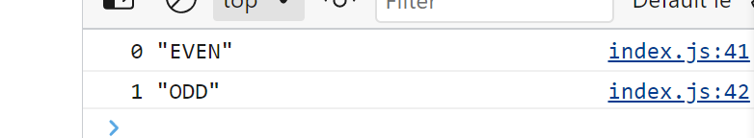

What was that return only numbers thing?

function fizzBuzz(input) {

    if (typeof input !== 'number')

   return 'Not a number'

}

Ok… this is my output:

showNumbers('dog');

function showNumbers(limit) {

    if (typeof limit !== 'number')

    return

    for (let i = 0;

    i <= limit;

    i++)

    {if (i % 2 === 0) console.log(i + ' ' + '"EVEN"')

    else if (i % 2 !== 0) console.log(i + ' ' + '"ODD"')

}

}

Ok, I got rid of some Pluses by odd and even:

showNumbers(100);

function showNumbers(limit) {

    if (typeof limit !== 'number')

    return

    for (let i = 0;

    i <= limit;

    i++)

    {if (i % 2 === 0) console.log(i + ' "EVEN"')

    else if (i % 2 !== 0) console.log(i + ' "ODD"')

}

}

So, let’s see Mosh’s solution.

“Here we need a *for* loop. Set our i variable to zero. As long as i is less than or equal to limit, we’re going to run this loop. And in every iteration, we’ll increment i”.

showNumbers(10);

function showNumbers(limit) {

for (let i = 0; i <= limit; i++) {

}

}

“Here we need to check if i is an even number or not. If i modulus 2 equals zero, we display console.log of i, and as a second argument we pass ‘EVEN’.” (((Ah, he used a coma instead of +)))

showNumbers(10);

function showNumbers(limit) {

for (let i = 0; i <= limit; i++) {

    if (i % 2 === 0) console.log(i, 'EVEN');

}

}

“Otherwise, we do a console.log of i and odd.” (((Ah, no need for any conditions))).

showNumbers(10);

function showNumbers(limit) {

for (let i = 0; i <= limit; i++) {

    if (i % 2 === 0) console.log(i, 'EVEN');

    else console.log(i, 'ODD');

}

}

“Instead of having two separate console.log statements, we can declare a constant. Call it Message. And here we can use the conditional operator.”

showNumbers(10);

function showNumbers(limit) {

for (let i = 0; i <= limit; i++) {

const message = (i % 2 === 0) ? 'EVEN' : 'ODD';

console.log(i, message);

}

}

Mosh thinks the turnery operator is cleaner and less noisy, but the first is fine as well.

My solution

showNumbers(100);

function showNumbers(limit) {

    if (typeof limit !== 'number')

    return

    for (let i = 0;

    i <= limit;

    i++)

    {if (i % 2 === 0) console.log(i + ' "EVEN"')

    else if (i % 2 !== 0) console.log(i + ' "ODD"')

}

}

first mosh solution

showNumbers(10);

function showNumbers(limit) {

for (let i = 0; i <= limit; i++) {

    if (i % 2 === 0) console.log(i, 'EVEN');

    else console.log(i, 'ODD')

}

}

*/

showNumbers(10);

function showNumbers(limit) {

for (let i = 0; i <= limit; i++) {

const message = (i % 2 === 0) ? 'EVEN' : 'ODD';

console.log(i, message);

}

}

## 04 - Control Flow - 15 - Exercise 6 - Count Truthy - 4.33

“Takes an array, and returns the number of truthy elements in this array”.

E.g,. “If we have an if statement, we may pass a Boolean true or false as the condition here:

if ()

function countTruthy(array) {

}

“E.g., we might have a constant called isactive… we set this to true.

const isActive = true;

if ()

function countTruthy(array) {

}

“When we use t his constant as the condition here, we get this hello message on the console”.

const isActive = true;

if (isActive) console.log('Hello');

function countTruthy(array) {

}

“But sometimes what we have in our *if* statement is not necessarily a Boolean value. It could be a string, it could be a number, it could be an object… so the JS engine tries to convert that value to something that is Like a Boolean but is Not a Boolean.”

“Let’s say we have a constant called name, and set it to the string Mosh.”

const isActive = true;

const name = 'Mosh';

if (isActive) console.log('Hello');

function countTruthy(array) {

}

“If I pass name here… obviously name is a string, it’s not a Boolean true or false. So, the JS engine tries to interpret this as truthy or falsy. When we run this, we still see the hello message, because we are still dealing with a string of characters. This is what we call a truthy value. It’s not a Boolean true… its truthy.

const isActive = true;

const name = 'Mosh';

if (name) console.log('Hello');

function countTruthy(array) {

}

“In contrast, if we had an empty string, JS would see this as falsy” “Now when we run this code, we no longer see the hello message.”

const isActive = true;

const name = '';

if (name) console.log('Hello');

function countTruthy(array) {

}

Here’s the list of falsy values in JS. “NaN is something I forgot to mention when I talked about all the falsy values in JS.”

* Undefined
* Null
* Empty string ‘’
* Boolean false
* 0
* NaN

“Your job is to create a function called count truthy that gets an array, and returns the number of truthy values in this array.”

“E.g., if I declare this array ((( const array = []))) and set it to [1, 2, 3]… so here we have 3 truthy values.

const array = [1, 2, 3];

function countTruthy(array) {

}

“We call count truthy, pass this array, and immediately pass this result to console.log” We get 3.

const array = [1, 2, 3];

console.log(countTruthy(array));

function countTruthy(array) {

}

If you add zero, you still get three, because zero is a falsy value.

const array = [0, 1, 2, 3];

console.log(countTruthy(array));

function countTruthy(array) {

}

If you add null, undefined, empty string, you still get 3:

const array = [0, null, undefined, '', 1, 2, 3];

console.log(countTruthy(array));

function countTruthy(array) {

}

Well, this is a tricky one. The console.log is exterior to the function. So, I have to somehow exclude falsy elements inside the array.

This doesn’t work:

const array = [0, null, undefined, '', 1, 2, 3];

console.log(countTruthy(array));

function countTruthy(array) { if (array = truthy)}

I mean… I could just run a number filter, so only numbers displayed? And also exclude 0?

First of all… how do we output anything?

This returns undefined.

const array = [0, null, undefined, '', 1, 2, 3];

console.log(countTruthy(array));

function countTruthy(array) {}

This is no good

const array = [0, null, undefined, '', 1, 2, 3];

console.log(countTruthy(array));

function countTruthy(array) {for (let array = [])

if [] = truthy}

Ok, I googled how to call an array with a function… and I got some strange results that aren’t quite applicable. Let’s see what I can figure out.

const array = [0, null, undefined, '', 1, 2, 3];

console.log(countTruthy(array));

function countTruthy(array) {let i = array

return (i)

}

This is displayed on the console:

(7) [0, null, undefined, '', 1, 2, 3]

This returns false:

const array = [0, null, undefined, '', 1, 2, 3];

console.log(countTruthy(array));

function countTruthy(array) {let i = array

return (i === typeof number)

}

This returns *[Array(7)]*.

const array = [0, null, undefined, '', 1, 2, 3];

console.log(countTruthy(array));

function countTruthy(array) {let i = array

return ([i])

}

Ah… maybe I should be paying more attention to the error messages.  
*Identifier 'i' has already been declared*

const array = [0, null, undefined, '', 1, 2, 3];

console.log(countTruthy(array));

function countTruthy(array) {let i = array

let i = (truthy || falsy;

}

Ok… this returns *[Array(7)]*

const array = [0, null, undefined, '', 1, 2, 3];

console.log(countTruthy(array));

function countTruthy(array) {return([array])

}

Returns *(7) [0, null, undefined, '', 1, 2, 3]*

const array = [0, null, undefined, '', 1, 2, 3];

console.log(countTruthy(array));

function countTruthy(array) {return (array)}

*NaN*

const array = [0, null, undefined, '', 1, 2, 3];

console.log(countTruthy(array));

function countTruthy(array) {return (array - 0)}

Just returns number of elements in the array:

const array = [0, null, undefined, '', 1, 2, 3, 4];

console.log(countTruthy(array));

function countTruthy(array) {

if (typeof array !== 'number')

return array.length

OK, I give up.

Mosh says, *let count = 0;*

const array = [0, null, undefined, '', 1, 2, 3, 4];

console.log(countTruthy(array));

function countTruthy(array) {

    let count = 0;

}

Now we’re supposed to use a *for of* loop, to iterate through the array.

So… I was an idiot… I reviewed Arrays, but did not continue my word search to watch other array videos. Duuuuuuuuuuuurrrrrr. Duuuur.

Ah ha… so, I am pulling from the for of video, as *for in* is outmoded. Here’s is the code I pulled from:

const colors = ['red', 'green', 'blue', 3, 5];

for (let color if colors)

console.log(color);

I have come up with this, so far.

const colors = ['red', 'green', 'blue', 3, 5];

for (let color of colors)

if (typeof color == 'number')

console.log(color.length)

OK, something like This is what I was looking for, though Mosh says this is bad. “You don’t want to have five conditions here for every falsy value”

const array = [0, null, undefined, '', 1, 2, 3, 4];

console.log(countTruthy(array));

function countTruthy(array) { for

    let (count = 0;)

    for (let value of array)

    if (value !== false || value !== undefined)

    count++;

    return count;

ff

“We simply pass that value here. Now that value might be a Boolean or a non Boolean. If it is Not a Boolean, the JS engine tries to interpret it as truthy or falsy. So if the **result** is truthy, then count will be incremented. Simple as that.

console.log(countTruthy(array));

function countTruthy(array) { for

    let (count = 0;)

    for (let value of array)

**if (value)**

    count++;

    return count;

}

Incidentally, I can’t get an output from the ‘wrong’ way:

const array = [0, null, undefined, '', 1, 2, 3, 4];

console.log(countTruthy(array));

function countTruthy(array) {

    let bob = 0;

    for (let value of array)

    if (value === 'number' || value !== false || value !== 0 || value !== null || value !== undefined || value !== '')

    bob++;

    return bob;

}

const array = [0, null, undefined, '', 1, 2, 3];

console.log(countTruthy(array));

function countTruthy(array) {

return (array.length,)

}

const array = [0, null, undefined, '', 1, 2, 3, 4];

console.log(countTruthy(array));

function countTruthy(array) {

    let count = 0;

}

const person = {

    name: 'Mosh',

    age: 30

};

for (let bob in person)

console.log(person[bob]);

const colors = ['red', 'green', 'blue', 3, 5];

for (let dave in colors)

console.log(colors[dave]);

for (let color of colors)

if (typeof color == 'string')

console.log(color)

for (let color if colors)

console.log(color);

I have come up with this, so far.

const colors = ['red', 'green', 'blue', 3, 5];

for (let color of colors)

if (typeof color == 'number')

console.log(color.length)

*/

const array = [0, null, undefined, '', 1, 2, 3, 4];

console.log(countTruthy(array));

function countTruthy(array) {

    let bob = 0;

    for (let value of array)

    if (value === 'number' || value !== false || value !== 0 || value !== null || value !== undefined || value !== '')

    bob++;

    return bob;

}

## 04 - Control Flow - Exercise 7 - String Properties

Create a function called showProperties. Pass an object here… and this function show display all the properties of this object that are of type string.

function showProperties(obj) {

}

“For example, we define an object like movie, and use the object literal syntax to initialize this [[[curly braces]]]. Here’ we’re going to add a few properties like *title*. We set it to a simple string… that value doesn’t really matter. A is enough. ReleaseYear… we set it to a number, like 2018.

Rating… again, a number. And then director… we set it to another string.

const movie = {

    title: 'a',

    releaseYear: 2018,

    rating: 4.5,

    director: 'b'

};

function showProperties(obj) {

}

“Now if we call this function, and pass this movie object, see what we get… the string properties of our movie object… title is a, and director is b.”

const movie = {

    title: 'a',

    releaseYear: 2018,

    rating: 4.5,

    director: 'b'

};

showProperties(movie);

function showProperties(obj) {

}

OK. Let’s hope we have a better time than last lesson.

We start out with regurgitating code from the object lesson. We predictably output the key value pairs, the properties of the movie object. (Freecodecamp says key and value together make a property).

const movie = {

    title: 'a',

    releaseYear: 2018,

    rating: 4.5,

    director: 'b'

};

showProperties(movie);

function showProperties(obj) { for (let key in movie)

    console.log(key, movie[key])

}

Letting key equal string just gives me the name/key, and undefined values:

const movie = {

    title: 'a',

    releaseYear: 2018,

    rating: 4.5,

    director: 'b'

};

showProperties(movie);

function showProperties(obj) { for (let key in movie)

    console.log(key, movie[key = 'string'])

}

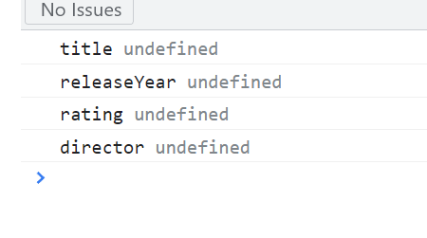

Same result for typeof

const movie = {

    title: 'a',

    releaseYear: 2018,

    rating: 4.5,

    director: 'b'

};

showProperties(movie);

function showProperties(obj) { for (let key in movie)

    console.log(key, movie[key ==  typeof string])

}

This gives us Just the values:

const movie = {

    title: 'a',

    releaseYear: 2018,

    rating: 4.5,

    director: 'b'

};

showProperties(movie);

function showProperties(obj) {

    for (let key in movie)

    if (key, movie[key])

    console.log(movie [key])

}

Ok… so we try dot notation:

const movie = {

    title: 'a',

    releaseYear: 2018,

    rating: 4.5,

    director: 'b'

};

showProperties(movie);

function showProperties(obj) {  movie.title = 'pig';

    console.log(movie.title)

}

Interesting… we try loose equality operator, and the value *a* is displayed. Same thing happens with an empty string.

const movie = {

    title: 'a',

    releaseYear: 2018,

    rating: 4.5,

    director: 'b'

};

showProperties(movie);

function showProperties(obj) {  movie.title == 'pig';

    console.log(movie.title)

}

Ah… the console.log returns the empty string for numbers.

const movie = {

    title: 'a',

    releaseYear: 2018,

    rating: 4.5,

    director: 'b'

};

showProperties(movie);

function showProperties(obj) {  movie.title == '';

movie.releaseYear == ''

movie.rating == ''

movie.director == 'bob'

    console.log(movie.title,

        movie.releaseYear)

}

Ok, I pulled some new code from online… and it did allow me to just display the object values… in an array? Not very useful, but an interesting trick all the same:

const movie = {

    title: 'a',

    releaseYear: 2018,

    rating: 4.5,

    director: 'b'

};

showProperties(movie);

function showProperties(obj) {

    console.log(Object.values(movie))

}

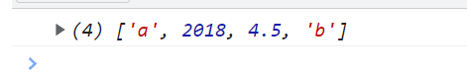

Ok, I give up. Mosh says to use the *for in* loop, to iterate over the properties of the object. So, in each iteration, this key will hold the name of one of **these** properties.

const movie = {

**title**: 'a',

**releaseYear**: 2018,

**rating**: 4.5,

**director**: 'b'

};

showProperties(movie);

function showProperties(obj) {

for (let key in obj)

}

Console.log of key:

const movie = {

    title: 'a',

    releaseYear: 2018,

    rating: 4.5,

    director: 'b'

};

showProperties(movie);

function showProperties(obj) { for (let key in obj)

    console.log(key);

}

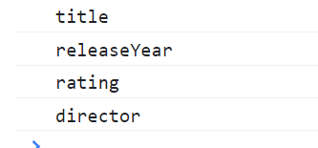

“Now we need to get the value of each of these properties, and then check the type of that value. If the type is a string, then we’ll display the property and its value”.

“To get the value of this property, we use the bracket notation. So, object of key”

const movie = {

    title: 'a',

    releaseYear: 2018,

    rating: 4.5,

    director: 'b'

};

showProperties(movie);

function showProperties(obj) {

    for (let key in obj)

    obj[key]

}

To check the type of this value, use the typeof operator…

const movie = {

    title: 'a',

    releaseYear: 2018,

    rating: 4.5,

    director: 'b'

};

showProperties(movie);

function showProperties(obj) {

    for (let key in obj)

    typeof obj[key]

}

“And then put this in an if statement. So, if the type of object of key equals string, then, display the key, as well as object of key”

showProperties(movie);

function showProperties(obj) {

    for (let key in obj)

    if (typeof obj[key] === 'string')

    console.log(key, obj[key]);

}

Mosh says, why not use curly braces after the for statement. That’s because there’s only a single statement, under the for statement. “The console dot log statement is a single statement that belongs to our *if* statement.” But curly braces also work.

const movie = {

    title: 'a',

    releaseYear: 2018,

    rating: 4.5,

    director: 'b'

};

showProperties(movie);

function showProperties(obj) {

    for (let key in obj)

    if (typeof obj[key] === 'string')

    console.log(key, obj[key]);

}

const movie = {

    title: 'a',

    releaseYear: 2018,

    rating: 4.5,

    director: 'b'

};

showProperties(movie);

function showProperties(obj) { for (let key in movie)

   if (typeof key movie[key] === 'string')

   console.log(key, movie[key])

}

Well, I wasn’t super far off. I simply couldn’t get the syntax right. Also, obj can be called movie, and it still works. A couple of my attempts are below… though I think I got closer.

function showProperties(obj) { for (let key in movie) if (key, movie[key == 'string'])

unction showProperties(obj) {

    for (let key in movie) if (key, movie[key == 'string']) return console.log

}

   console.log(key, movie[key ==  typeof string])

## 04 - Control Flow - 17 - Exercise 8 - Sum of Multiples of 3 and 5

Mosh says this is another easy one. Thanks Mosh. You know, that hard one a while back wasn’t so hard. These ‘easy’ lessons kinda suck. You know… maybe you’re just a bad teacher… had you thought about that? Maybe you should incorporate some review lessons, before throwing us into the deep end, and demoralizing the slower members of the class like myself. Maybe… you’re just a Sadist. You came from Iran. I’m thinking… ex intelligence? Interrogator… Teacher. They’re almost the Same thing when you think about it. I’m thinking… you used coercion to extract information like secret codes… and now you’re laughing at all of us… as you still try to extract code from your students… code that aren’t in a position to give you. And you watch us sweat. You know… hell is real, Mosh. It’s full of pirates, and lawyers, and Assholes.

This function will return all the multiples of 3 and 5 from zero up to this limit.

console.log(sum(10));

function sum(limit) {

}

What are the multiples of 3 and 5 between zero and ten? Multiples of 3 are 3, 6 and 9. Multiples of 5, are 5 and 10… including the number that is passed as a limit. If you add all these numbers together… the result will be 33.

Ok, so we have to iterate through a number until we hit the limit… that’s easy enough, I guess. And then we have to do the same for 5. And then add the numbers together.

So… which loop is best to use?

Well… *Do while* loops seem to execute at least Once, not matter what. And *for in* and *for of* may be made specifically for objects and arrays, which we are not ((turn the timer back on!)) using.

The While loop is similar, except that the loop variable is outside the loop.

Alright, my usual outputting woes. Nothing but errors. Ah… first, is unexpected token ‘;’ at the end of the for line.

console.log(sum(10));

function sum(limit) {

for (let i = 0; i <= limit; i++;);

return

}

Ok, now we are undefined.

console.log(sum(10));

function sum(limit) {

for (let i = 0; i <= limit; i++);

}

So… do we avoid using magic numbers? Do we define a couple variables?

Ok… maybe we need an internal console.log, so we can at least see what we are outputting.

So… with an internal console.log, nothing posts, because there is nothing to call our function:

function sum(limit) {

for (let i = 0; i <= limit; i++);

console.log(i)

}

Uncaught ReferenceError: i is not defined

at sum (index.js:126:13)

at index.js:119:1  
So… does this mean that console.logs inside functions don’t work?

sum(10)

function sum(limit) {

for (let i = 0; i <= limit; i++);

console.log(i)

}

Ok, back to original code. Return 5, gives us 5 on the console.

console.log(sum(10));

function sum(limit) {

return 5

}

Ok… finally something on the console:

console.log(sum(10));

function sum(limit) {

    let i = 0;

    while ((i * 3) <= limit) {console.log(i++)}

}

0

1

2

3

index.js:119 undefined

This is an infinite loop.

console.log(sum(10));

function sum(limit) {

    let i = 0;

    while ((i * 3) <= limit) {console.log(i)}

Another infinite loop:

console.log(sum(10));

function sum(limit) { let i = 1;

while ((3 * i) <= limit)

console.log(sum)

i++; }

Ok… defining sum returns sum. Can we make sum the sum of two separate statements?

console.log(sum(10));

function sum(limit) { sum = 22;

    return sum

}

Ok, this returns 27.

function sum(limit) {

    let fiver = 7

    let threes = 20

    let sum = (fiver + threes);

    return sum

}

OK… this takes me up to 99 on the console. But I don’t want to add 1, I want to add the sum of bob and bob.

for (let bob = (5 + 5); bob < 100; bob++)

console.log(bob);

OK. Instead of console.loging i, we logged the (i *3) expression, and got 3, 6, 9 on the console.

console.log(sum(10));

function sum(limit) {

    for (let i = 1; (i * 3) <= limit; i++)

    console.log((i * 3))

}

Ok… added a second for statement, and got interesting results… I think the second i * 5 statement, truncated the i * 3 iterations.

console.log(sum(10));

function sum(limit) {

    for (let i = 1; (i * 3) <= limit; i++)

    for (let i = 1; (i * 5) <= limit; i++)

    console.log((i * 3))

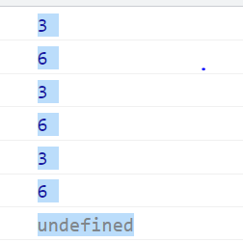

OK. This is another interesting result:

console.log(sum(10));

function sum(limit) {

    for (let i = 1; (i * 3) <= limit; i++)

    for (let b = 1; (b * 5) <= limit; b++)

    console.log((i * 3) + (b * 5))

}

3 and 5 make 8. 8 and 5 make 15. Next loop. 6 & 5 make 11. 11 and 5 make 16. Third loop 9 and 5 make 14. 14 and 5 make 19.

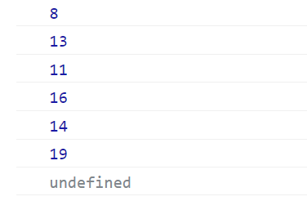

So, if we use logical or, we get 8 and 16 as the output:

console.log(sum(10));

function sum(limit) {

    for (let b = 1; (b * 3) <= limit && (b * 5) <= limit; b++)

    console.log((b * 5) + (b * 3))

Returning limit gives us:

console.log(sum(10));

function sum(limit) {

    for (let b = 1; (b * 3) < limit; b++)

   console.log(limit)

}

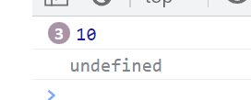

OK… so I eventually gave up and googled the answer.

https://www.codegrepper.com/code-examples/javascript/For+loop+sum+in+javascript

*sp: output loops into a sum js*

The problem is, we need some kind of Container as we iterate through the numbers. The answer is to define a variable as zero before the *for* statement (the function doesn’t work if you define if after the *for* statement… because it becomes subservient to the *for* statement?), and then after the *for* statement, you redefine the variable as *variable equals variable plus* Second *variable*. Because it is *after* the *for* statement, perhaps the for statement is Acting upon it.

console.log(sum(10));

function sum(limit) {

let threez = 0;

    for (let b = 1; ((b * 3) <= limit); b++)

   threez = threez + (b * 3)

I still had some trouble incorporating the Second statement… they kept interacting with each other weirdly, even if I assigned separate variables. But it occurred to me that the same set of rules may apply. So, I defined the next variable, and vola.

console.log(sum(10));

function sum(limit) {

let threez = 0;

    for (let b = 1; ((b * 3) <= limit); b++)

   threez = threez + (b * 3)

   let fiver = 0;

   for (let i = 1; ((i * 5) <= limit); i++)

   fiver = fiver + (i * 5)

   let sum = (threez + fiver)

    return sum

}

After looking ahead at Mosh’s solution, I see a couple interesting things. If we remove the *x = x + y*, and simply output *x + y*, the console outputs to zero:

console.log(sum(10));

function sum(limit) {

let threez = 0;

    for (let b = 1; ((b * 3) <= limit); b++)

    threez + (b * 3)

   let fiver = 0;

   for (let i = 1; ((i * 5) <= limit); i++)

    fiver + (i * 5)

   let sum = (threez + fiver)

    return sum

}

But… if we output +=, aka the addition assignment operator (it adds the value of the Right operand to the variable), we can simplify the code.

console.log(sum(10));

function sum(limit) {

let threez = 0;

    for (let b = 1; ((b * 3) <= limit); b++)

    threez += (b * 3)

   let fiver = 0;

   for (let i = 1; ((i * 5) <= limit); i++)

    fiver += (i * 5)

   let sum = (threez + fiver)

    return sum

}

Let us see Mosh’s fancy solution.

Mosh starts with a for loop. Let i equal zero. So long as i is less than or equal to limit… increment i. Let’s see if we can run with that. Nope.

“Now we need to check to see if i is a multiple of 3 or 5.”

function sum(limit) {

    for (let i = 0; i <= limit; i++)

    if (i % 3 === 0 || i % 5 === 0)

}

“Now we need to take i and add it to our sum. Here we need to declare a variable, let sum, set it to zero”.

console.log(sum(10));

function sum(limit) {

let sum = 0;

    for (let i = 0; i <= limit; i++)

    if (i % 3 === 0 || i % 5 === 0)

}

“if i is a multiple of 3 or 5, we need to add 5 to sum. And finally, return sum”.

console.log(sum(10));

function sum(limit) {

let sum = 0;

    for (let i = 0; i <= limit; i++)

        if (i % 3 === 0 || i % 5 === 0)

            sum += i;

    return sum;

}

“Now pay attention to how I have formatted this code. I have added these extra vertical line breaks to separate the initialization, from the actual logic, from the return value.”

console.log(sum(10));

function sum(limit) {

    let sum = 0;

for (let i = 0; i <= limit; i++)

        if (i % 3 === 0 || i % 5 === 0)

            sum += i;

    return sum;

}

“If we didn’t have these vertical breaks, the code would look a little bit squashed… a little bit hard to read. As a best practice, it is always good to separate the last line… the return statement.”

“In this case, we can have all these lines together, because they are Highly related.”

console.log(sum(10));

function sum(limit) {

let sum = 0;

    for (let i = 0; i <= limit; i++)

        if (i % 3 === 0 || i % 5 === 0)

            sum += i;

    return sum;

}

“But some developers prefer to separate the initialization, so you could add a line break here as well.

“But what I want you to take away is that lines that are highly related should be together, and they should be separate from other lines”

console.log(sum(10));

function sum(limit) {

    let sum = 0;

for (let i = 0; i <= limit; i++)

        if (i % 3 === 0 || i % 5 === 0)

            sum += i;

    return sum;

}

Ah… an elegant solution. He just divided all the numbers under 10 by 3 or 5, and added it to a sum. He didn’t have to perform any multiplications.